O365 | User name change for Microsoft OneDrive (2013 & 2016) desktop application

Once your user name has been updated it may take up to 24 hours for it to take effect across all Office 365 (O365) Services. After the change has taken effect, you will have to sign into Outlook, Skype for Business, OneDrive for Business and other O365 services with the updated user name. Following are directions for changing your user name within desktop applications.

OneDrive for Business – Sync Client
Within 24 hours of your user name being changed, your OneDrive synchronization to your desktop will break. To restore synchronization of your OneDrive, complete the steps below.
STEP | DESCRIPTION | EXAMPLE
1 | Sign into the O365 web portal (https://login.microsoftonline.com/ ) with your new user name:  Employees / Guest: yourStarID@minnstate.edu  Students: yourStarID@go.minnstate.edu  NOTE: If you have a Mac, see OneDrive sync client on Mac OS X <http://tinyurl.com/jnjb23e>
2 | Click on the OneDrive tile
3 | Select Sync
4 | Select Sync Now  Once synchronization completes, your OneDrive will be accessible within your local Microsoft applications (Word, Excel, etc.) and within Windows Explorer

Troubleshoot OneDrive for Business – Sync
STEP | DESCRIPTION
1 | Determine which OneDrive sync client you're using or need to install | If you’re not sure which version of OneDrive you’re using, or which version of the OneDrive sync client you need, follow instructions on this site.  <http://tinyurl.com/htxcns2>
2 | Install the latest OneDrive sync app, which will prompt you for your updated credentials  In the lower-left of the OneDrive web app, click Get the OneDrive apps | 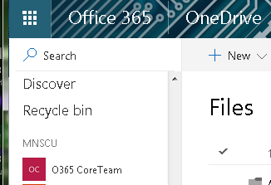
3 | Click Download | 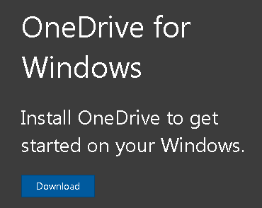
4 | Click Save File | 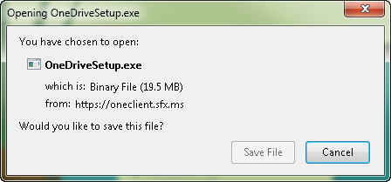
5 | Install the file and follow the steps provided

