O365 | User name change for Microsoft Skype (2013 & 2016) desktop application

Once your user name has been updated it may take up to 24 hours for it to take effect across all Office 365 (O365) Services. After the change has taken effect, you will have to sign into Outlook, Skype for Business, OneDrive for Business and other O365 services with the updated user name. Following are directions for changing your user name within desktop applications.

Skype for Business User Name Change
STEP | DESCRIPTION | EXAMPLE
1 | If starting your PC for the first time after the username change, and Skype is in your Start Menu you may be prompted for credentials.  Click Cancel. Skip to step 3
2 | Sign out of Skype, if signed in
3 | Click Delete my sign-in info | 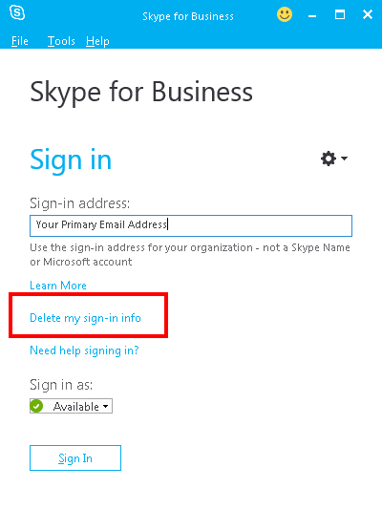
4 | Within the forget sign-in information pop-up, click Yes | 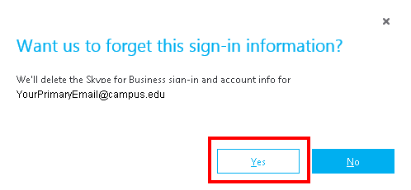
5 | - Enter your new user name  Employees/Guest: yourStarID@minnstate.edu  Students: yourStarID@go.minnstate.edu  - Enter your StarID password  OPTIONAL: Select Save my password to save credentials  - Click Sign In | 