O365 | User name change for Web Portal

Once your account user name has changed, you will need to update your user name to log in to the Office 365 web portal: https://login.microsoftonline.com OR https://portal.office.com
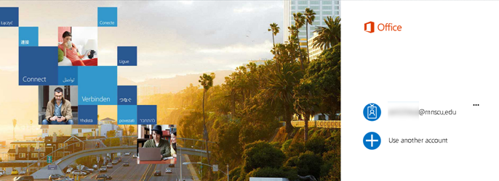
Follow the directions below to update your user name.
STEP | DESCRIPTION | EXAMPLE
 | NOTE:  If you attempted to log in and received the following error:  “We don’t recognize the user ID or password” (as shown in the example on the right)  …click the Back button | 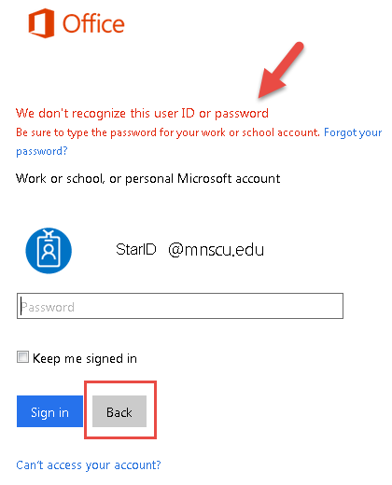
1 | Open a browser and go to the portal page  https://login.microsoftonline.com OR https://portal.office.com  Click Use another account
2 | - Enter your new user name  Employees / Guest: yourStarID@minnstate.edu  Students: yourStarID@go.minnstate.edu  - Enter your StarID password  - Click Sign in | 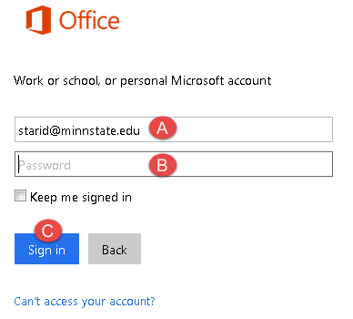
 | Recommended:  After adding your new user name to the sign in page, remove the old user name to prevent any confusion.  To the right of the old user name, click the ellipses, and then click Forget. | 