O365 | User name change for iOS Built-in Email App

Once your user name has been updated it may take up to 24 hours for it to take effect across all Office 365 (O365) services. After your account has been updated for each service (Outlook, Skype for Business, OneDrive for Business and other O365 apps) you will need to sign in to the service with the updated user name. Below are directions for changing your user name within the iOS built-in email app.
Need to set up a new account? Jump to the new mail account section

User Name Change for Built-in iOS Email App Account
STEP | DESCRIPTION
 | After your user name has been changed, you’ll see a message like the one to the right when attempting to access mail on your device.  Click Cancel | 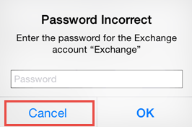
1 | Tap the Settings tile | 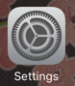
2 | Tap Mail, Contacts, Calendars | 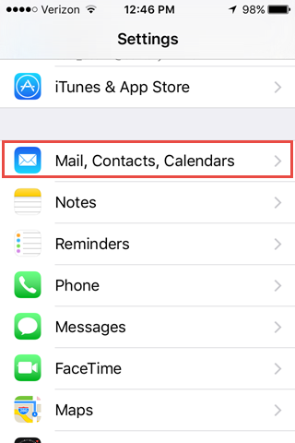
3 | Tap Exchange | 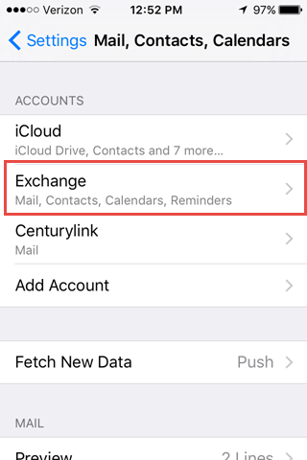
4 | Enter the primary email address of your account | 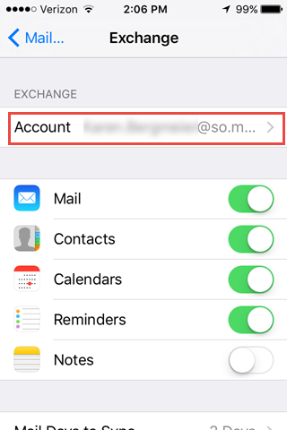
5 | Update your user name  Employees/Guest: yourStarID@minnstate.edu  Students: yourStarID@go.minnstate.edu  Enter your StarID password  Tap Sign in  Tap Done  Exit Settings | 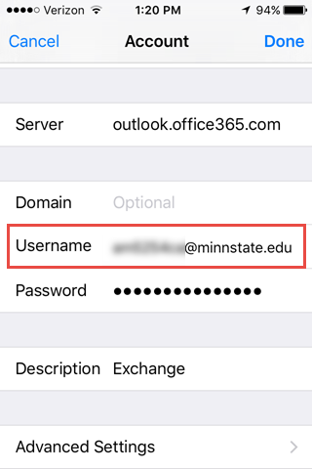

Add New Account
STEP | DESCRIPTION
1 | Tap the Settings tile
2 | Tap Mail, Contacts, Calendars
3 | Under Accounts Tap Add Account | 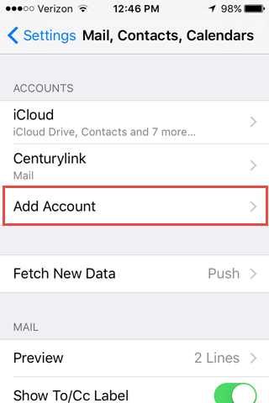
4 | Tap Exchange | 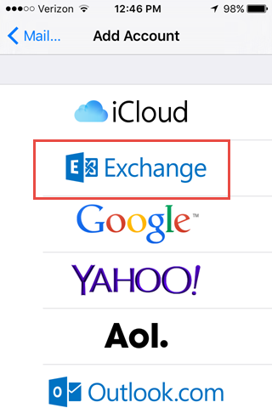
5 | Scroll down and complete these fields:  Email (Primary email address)  StarID password  Server: Enter outlook.office365.com  Domain: Leave empty  User name:  Employees/Guest: yourStarID@minnstate.edu  Students: yourStarID@go.minnstate.edu  Password: StarID password  Tap Next | 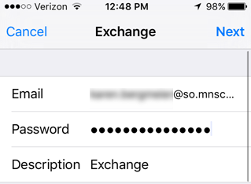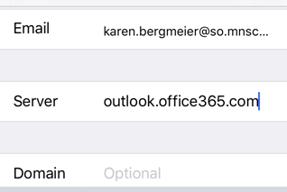  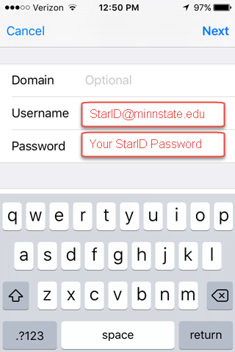
6 | Recommended:  Under the Exchange settings, tap Mail Days to Sync and consider the number of days mail needs to remain synced to your device. The longer the time period, the longer it may take to load messages on your device and the more space they will use. | 