O365 | User name change for Outlook app for iOS

Once your user name has been updated it may take up to 24 hours for it to take effect across all Office 365 (O365) services. After your account has been updated for each service (Outlook, Skype for Business, OneDrive for Business and other O365 apps) you will need to sign in to the service with the updated user name. Below are directions for changing your user name within the Outlook app for iOS.
The Outlook app is the recommended way to access Office 365 mail on your iOS device. Unlike the iOS native email and calendar clients, the Outlook app is fully supported by Microsoft.
Don’t have the Outlook app on your iOS device? Start with the download section.

User Name Change
STEP | DESCRIPTION
 | On a scheduled date in 2017, the Minnesota Office 365 Single Tenant User Principle Name (UPN), or user name, changes from @mnscu.edu to @minnstate.edu. Students, staff and guests using the iOS Outlook app will need to reconnect their device(s) and the most common way to do this is to remove the existing account and add it back with the new user name.
 | NOTE:  Continue to access mail on your iOS device until the app fails to connect using the old user name. | 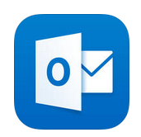
1 | When prompted to log in:  Tap Login | 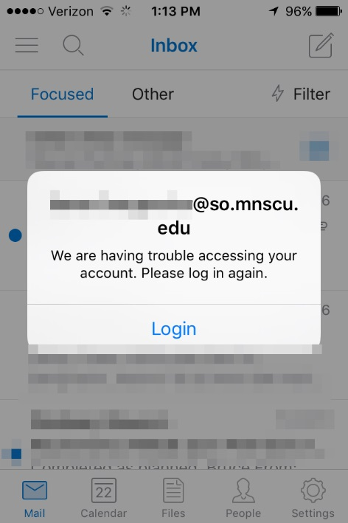
2 | Tap Delete Account  Go to next section (Add Account), Step 2 | 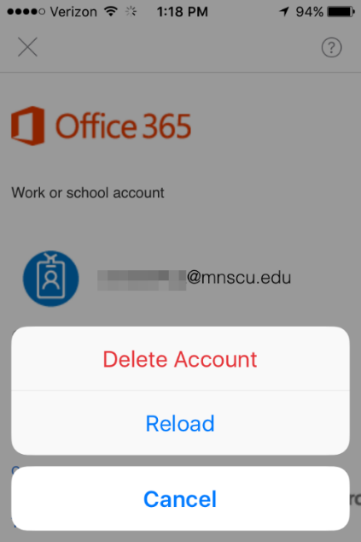

Add Account
STEP | DESCRIPTION
1 | Open the Outlook app
2 | Tap Get Started | 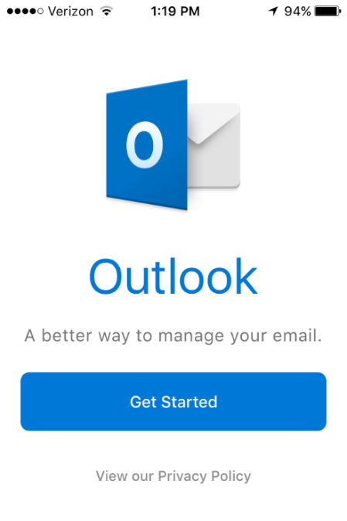
3 | Tap in the email address area, then use the keyboard to enter your primary email address  Tap Add Account | 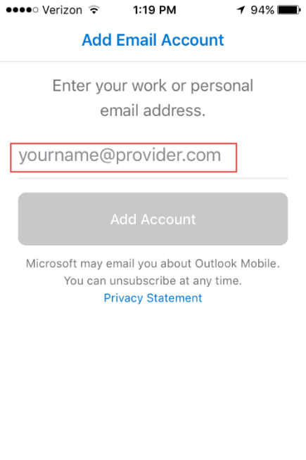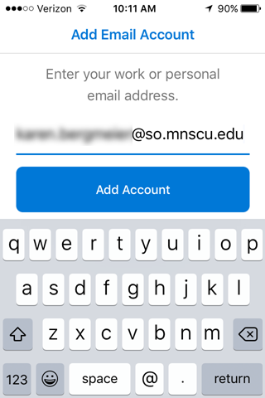  Primary-Email@campus.edu
4 | On the Office 365 pane, remove your email address  Enter your new user name  Employees/Guest: yourStarID@minnstate.edu  Students: yourStarID@go.minnstate.edu  Enter your StarID password  Tap Sign in | 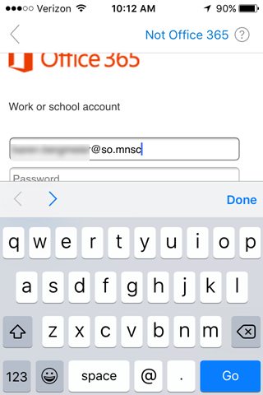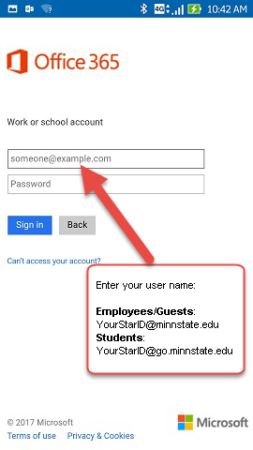  Replace email with user name
5 | Tap Maybe Later (unless you have a second account to add). | 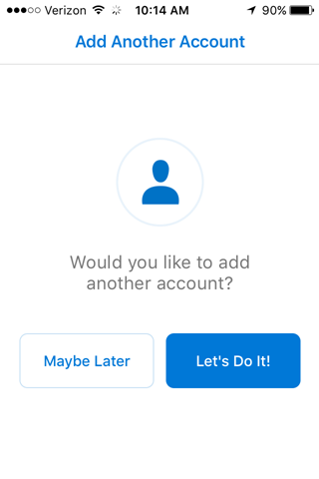
6 | Tap Skip, or go through the informational slides.  Your Inbox displays | 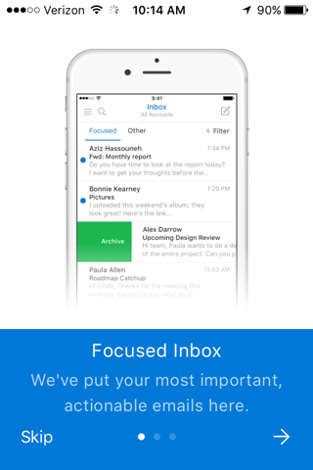

Prerequisite: iOS 8.0 or higher.

Download the app from the Apple Store
STEP | DESCRIPTION
1 | If the Outlook app is not already on the device, open the App Store and search for “Outlook 365” | 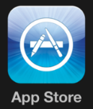
2 | Open / install the Microsoft Outlook – email and calendar app | 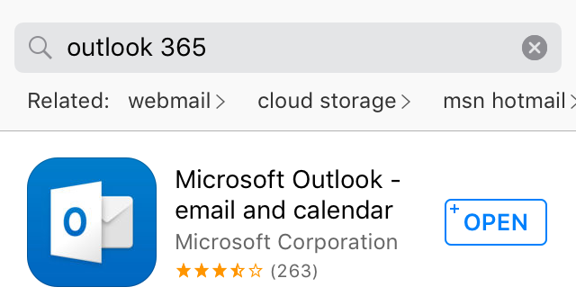

Add an Account
STEP | DESCRIPTION
1 | Open the Outlook app | 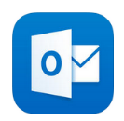
2 | Tap GET STARTED | 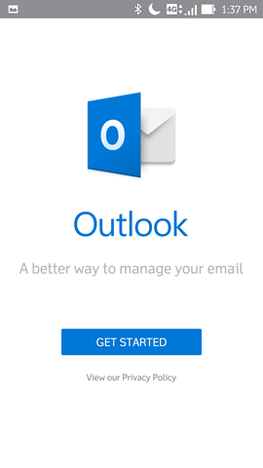
3 | Tap in the email address area and enter your primary email address  Tap CONTINUE  Enter your user name. If your email address is already in the field, change it to your user name  Employees/Guest: YourStarID@minnstate.edu  Students: YourStarID@go.minnstate.edu  Enter your StarID Password  Tap Sign in | 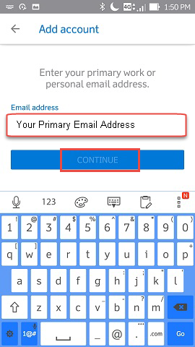
4 | Tap MAYBE LATER, unless you have another account to add  Your Inbox displays | 