O365 | Configure Android Built-in Email App

Once your user name has been updated it may take up to 24 hours for it to take effect across all Office 365 (O365) services. After your account has been updated for each service (Outlook, Skype for Business, OneDrive for Business and other O365 apps) you will need to sign in to the service with the updated user name. Below are directions for changing your user name within the Android built-in email app.
Android mail apps may look different across different devices, and these directions may not exactly match the options you see. Use these steps as a guide or consult the manufacturer's help for your particular device.
Need to add an Office 365 account? Jump to the Add Account section.

User Name Change – Remove Old Account/User Name
STEP | DESCRIPTION | Example
1 | Open Email Inbox  Tap More (ellipses icon)  Tap Settings | 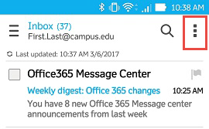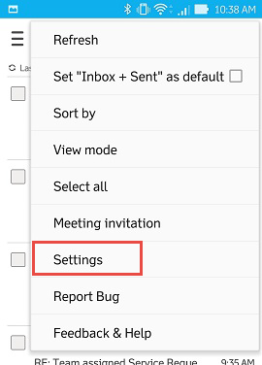
2 | Tap the name or address or your account  Tap Remove account  Tap OK when prompted  Swipe down the account setting options to Remove account  Tap Remove account  Tap OK when prompted | 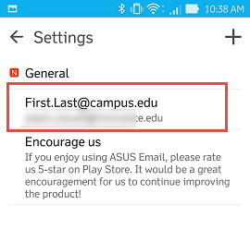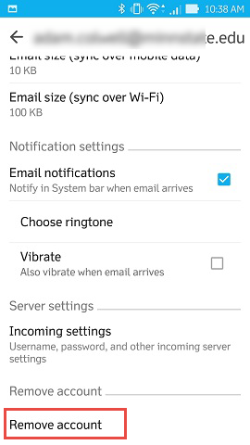

Add Account
STEP | DESCRIPTION | Example
1 | Tap Settings tile  Tap Accounts | 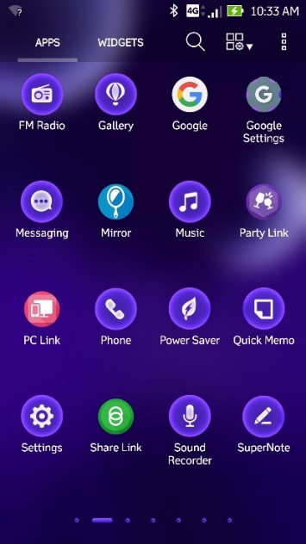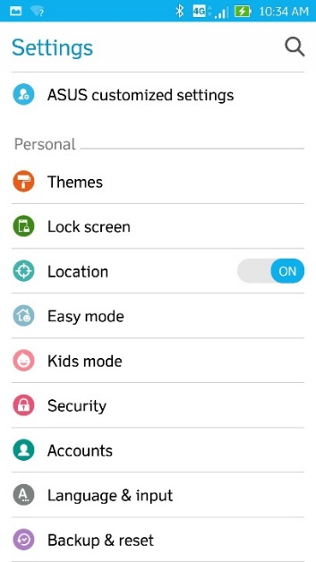
2 | Tap Add account  Tap Email | 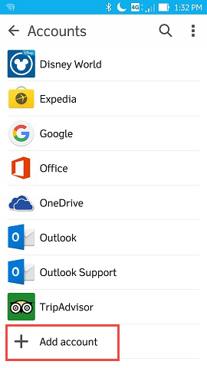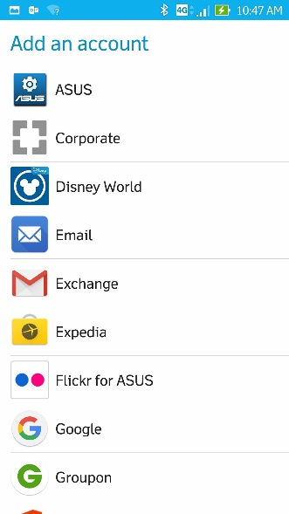
3 | Tap Exchange as mail provider | 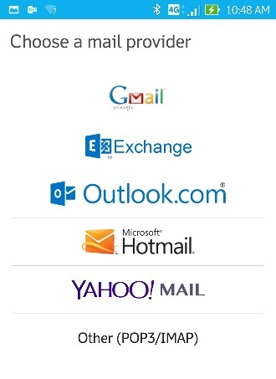
4 | In the email address field, enter your primary email address  Enter your StarID password  Click Next  In Domain\Username field, enter your new user name  Employees: StarID@minnstate.edu  Student: StarID@go.minnstate.edu  In Server field, enter: outlook.office365.com  Scroll down, tap Next | 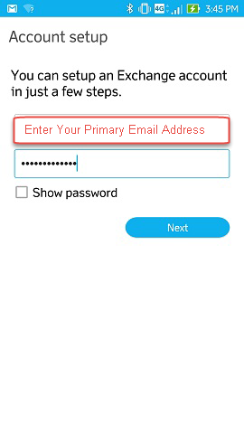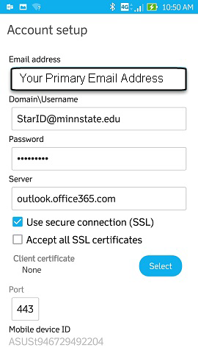
5 | On Account Settings screen, tap Next  Optional: Keep the default account name or give it a new name.  Click Next.  Email app now contains your campus mail. | 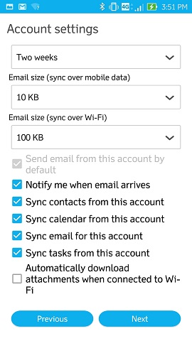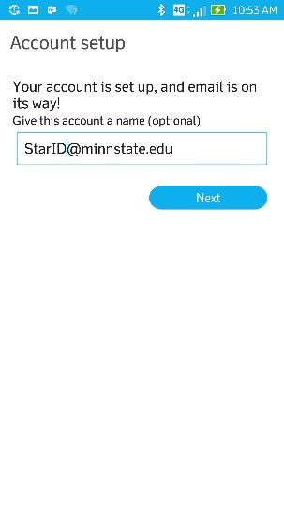

The Android Contacts App
STEP | DESCRIPTION
 | View your contacts with the default Contacts app on Android. This allows you to easily see the name of a contact when you receive a call or text message from them, and view all of their contact information directly in the default Contacts app.
4 | Tap / open Contacts app | 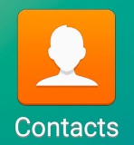
5 | Tap More options (ellipsis icon)  Tap Settings | 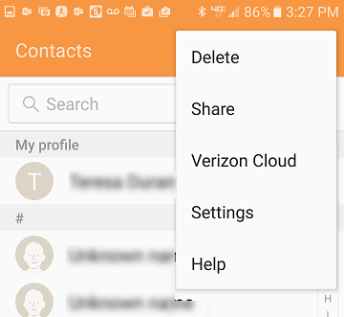
6 | Tap Contacts to display | 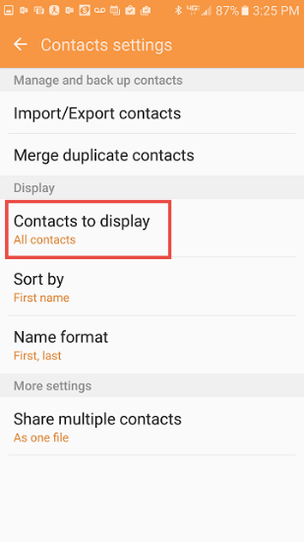
7 | The accounts you have configured on the device all display by default.  Control which contacts display in your Android Contacts app – change at any time. | 