O365 | User name change for Android – Outlook App

Once your user name has been updated it may take up to 24 hours for it to take effect across all Office 365 (O365) services. After your account has been updated for each service (Outlook, Skype for Business, OneDrive for Business and other O365 apps) you will need to sign in to the service with the updated user name. Below are directions for changing your user name within the Outlook app for Android.
Don’t have the Outlook app for Android? Start with the install, and then add a new account

Change User Name
STEP | DESCRIPTION
 | In 2017, the Minnesota Office 365 Single Tenant User Principle Name (UPN), or user name, changes from @mnscu.edu to @minnstate.edu. Staff at the system office using the Android Outlook app will need to reconnect their device(s) and the easiest way to do this is to remove the existing account and add it back with the new user name.
Start from Outlook
NOTE: Deleting the account from within the Outlook app will automagically prompt you to add the account back with the new user name and retain many settings. Deleting from Android Settings may require you to fully configure the new account.
1 | Tap to open the Outlook app | 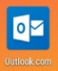
2 | Tap Settings  Tap account name | 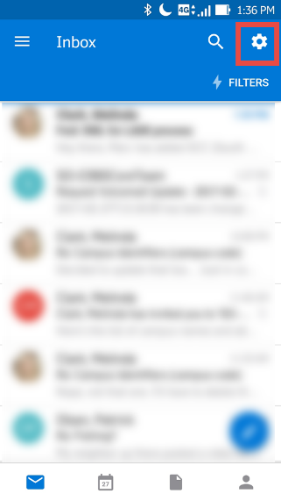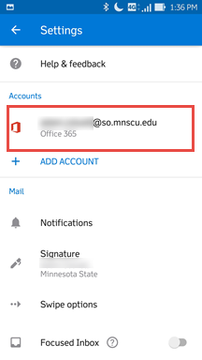
3 | Tap DELETE ACCOUNT  Tap DELETE | 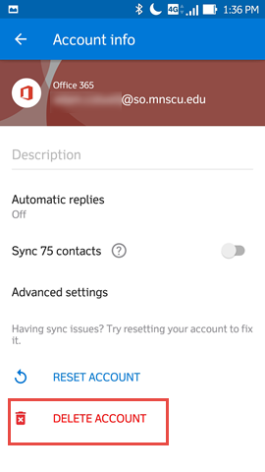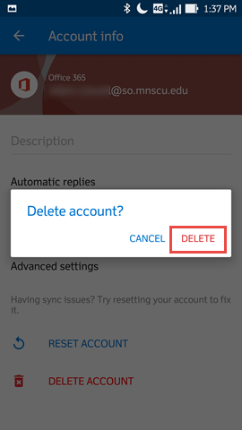
4 | After deleting the account, the app will prompt you to add an account  Tap GET STARTED | 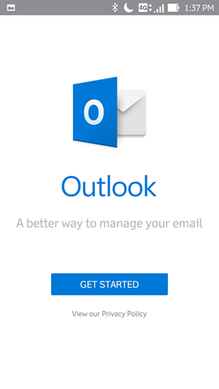
5 | Tap in the email address area, then use the keyboard to enter your primary email address  Tap CONTINUE  Enter your new user name:  Employees/Guest: YourStarID@minnstate.edu  Students: YourStarID@go.minnstate.edu  Enter your StarID Password  Click Sign in | 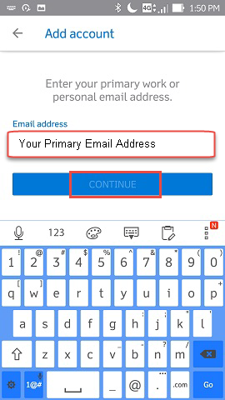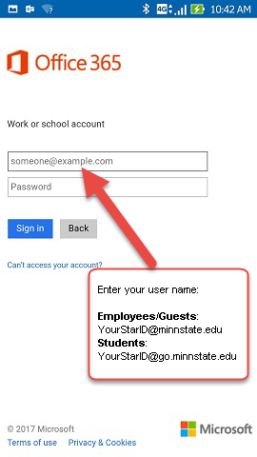
6 | Your Inbox will display

Download the app from the Google Play Store
STEP | DESCRIPTION
1 | If the Outlook app is not already on the device, open the Google Play store
2 | Search for the Microsoft Outlook app  Open/Install | 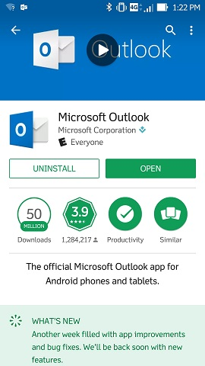

Add an Account
STEP | DESCRIPTION
1 | Open the Outlook app
2 | After deleting the account, the app will prompt you to add an account  Tap GET STARTED
3 | Tap in the email address area, then use the keyboard to enter your primary email address  Tap CONTINUE  Enter your user name. If your email address is already in the field, change it to your user name  Employees/Guest: YourStarID@minnstate.edu  Students: YourStarID@go.minnstate.edu  Enter your StarID Password  Tap Sign in
4 | Tap MAYBE LATER, unless you have another account to add  Your Inbox will display | 