O365 | User name change for Web Portal – System Office Staff - February 28, 2017

Follow the directions below to update your Office 365 user name to log in to the Office 365 web portal.
STEP | DESCRIPTION
 | If you attempted to log in with the old username and ended with the following error  “We don’t recognize the user ID or password” (as shown in the example on the right)  …click the Back button. | 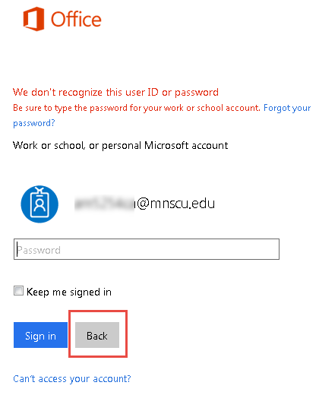
1 | Click Use another account | 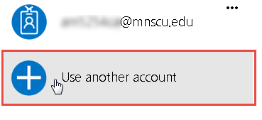
2 | - Enter your new user name  - Enter your StarID password  - Click Sign in | 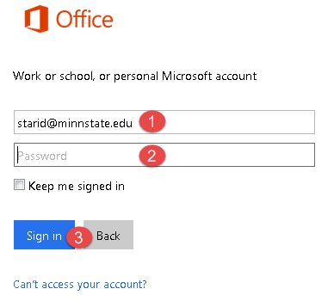
3 | To remove the old user name from the log in window, click the ellipses, then click Forget. | 