O365 | User name change for Microsoft (2013 & 2016) desktop applications – System Office - February 28, 2017

After the user name change you will have to sign into Outlook, Skype for Business, OneDrive for Business and other O365 services with the updated user name. Below are directions for changing your user name within desktop applications.
Outlook
Skype for Business
OneDrive for Business – Sync Client
OneNote

Outlook User Name Change
STEP | DESCRIPTION
1a | If starting your PC for the first time after the username change, and Outlook is in your Start Menu you will be prompted for credentials automatically. Skip to step 3
1b | If Outlook is closed, start Outlook – skip to Step 3
1c | If working in Outlook, continue to work in Outlook until the Send/Receive connection breaks. The connection status is located at the bottom-right of the Outlook window.
2 | Exit and re-open Outlook to be prompted for your new user name credential
3 | - Enter your new user name  StarID@minnstate.edu  - Enter your StarID password  OPTIONAL: Select Remember my credentials to save credentials  - Click OK to sign in | 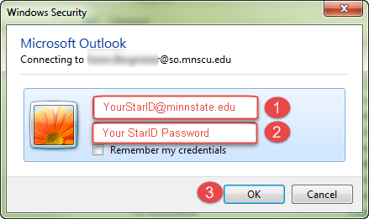

Skype for Business User Name Change
STEP | DESCRIPTION
1 | If starting your PC for the first time after the username change, and Skype is in your Start Menu you will be prompted for credentials automatically. Cancel. Skip to step 3
2 | Sign out of Skype, if signed in
3 | Click Delete my sign-in info | 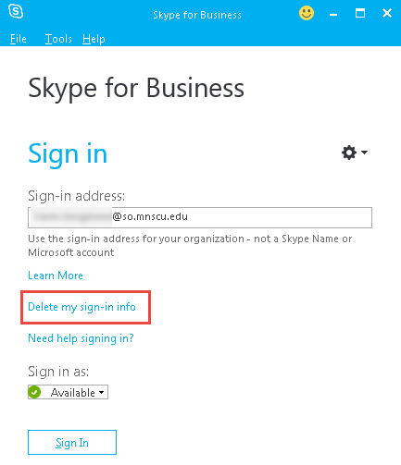
4 | Within the forget sign-in information pop-up, click Yes | 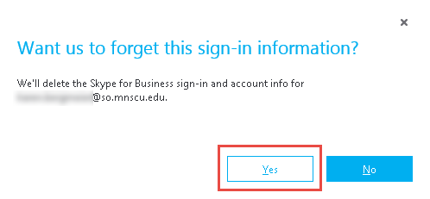
5 | - *Enter your new user name  - Enter your StarID password  - OPTIONAL: Select Save my password to save credentials  - Click Sign In  *You may need to click Sign In first.  NOTE: If you don’t get the User Name option (example to the right) immediately after clicking “forget this sign-in information:”  - Do not enter your password  - Click Sign In  - Click Cancel | 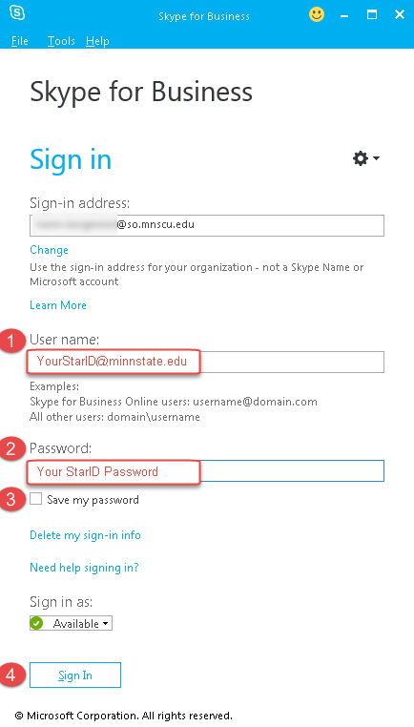

OneDrive for Business – Sync Client
To restore synchronization of your OneDrive, complete the steps below.
STEP | DESCRIPTION
1 | Sign into the O365 web portal (https://login.microsoftonline.com/ ) with your new user name:
2 | Click on the OneDrive tile
3 | Select Sync
4 | Select Sync Now  Once synchronization completes, your OneDrive will be accessible within your local Microsoft applications (Word, Excel, etc.) and within Windows Explorer.
5 | Problems?  Determine which OneDrive sync client you're using or need to install | If you’re not sure which version of OneDrive you’re using, or which version of the OneDrive sync client you need, follow instructions on this site. (https://tinyurl.com/jbbhu6p)  If you have a Mac, skip to the OneDrive sync client on Mac OS X.
6 | Install the latest OneDrive sync app, which will prompt you for your updated credentials  In the lower-left of the OneDrive web app, click Get the OneDrive apps | 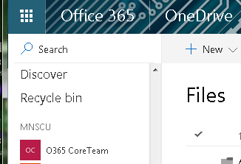
7 | Click Download
8 | Click Save File | 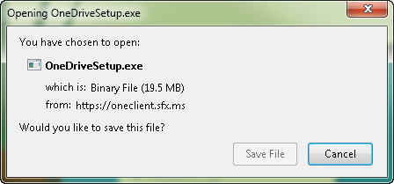
9 | Install the file and follow the steps

OneNote
To restore synchronization of OneNote, complete the steps below.
STEP | DESCRIPTION
1 | Sign into the O365 web portal (https://login.microsoftonline.com/ ) with your new user name:
2 | Click on the OneNote tile |  | 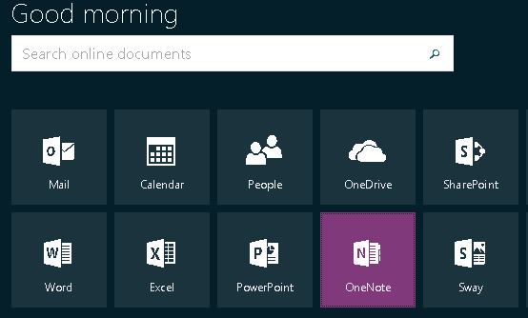
3 | From the My Notebooks view, click the name of a notebook |  | 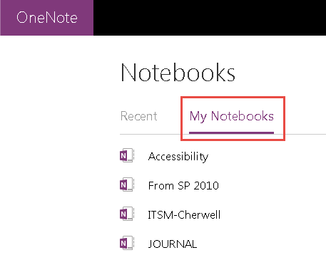
4 | In the open notebook, click Edit in OneNote | OneNote will open and the notebook will sync
5 | If OneNote creates a new local notebook instead of syncing to the existing notebook, wait for it to finish creating/syncing the new notebook and then right-click on the old notebook and click Close This Notebook. |  | 