Consortium Membership List

When you get to this question in AMPLIFUND, just click the Mark as Complete button and move to the next question. We made a technical error that can’t be fixed while applications are live.

The solution: Complete this document and upload it under the section called ADDITIONAL DOCUMENTS in AMPLIFUND.

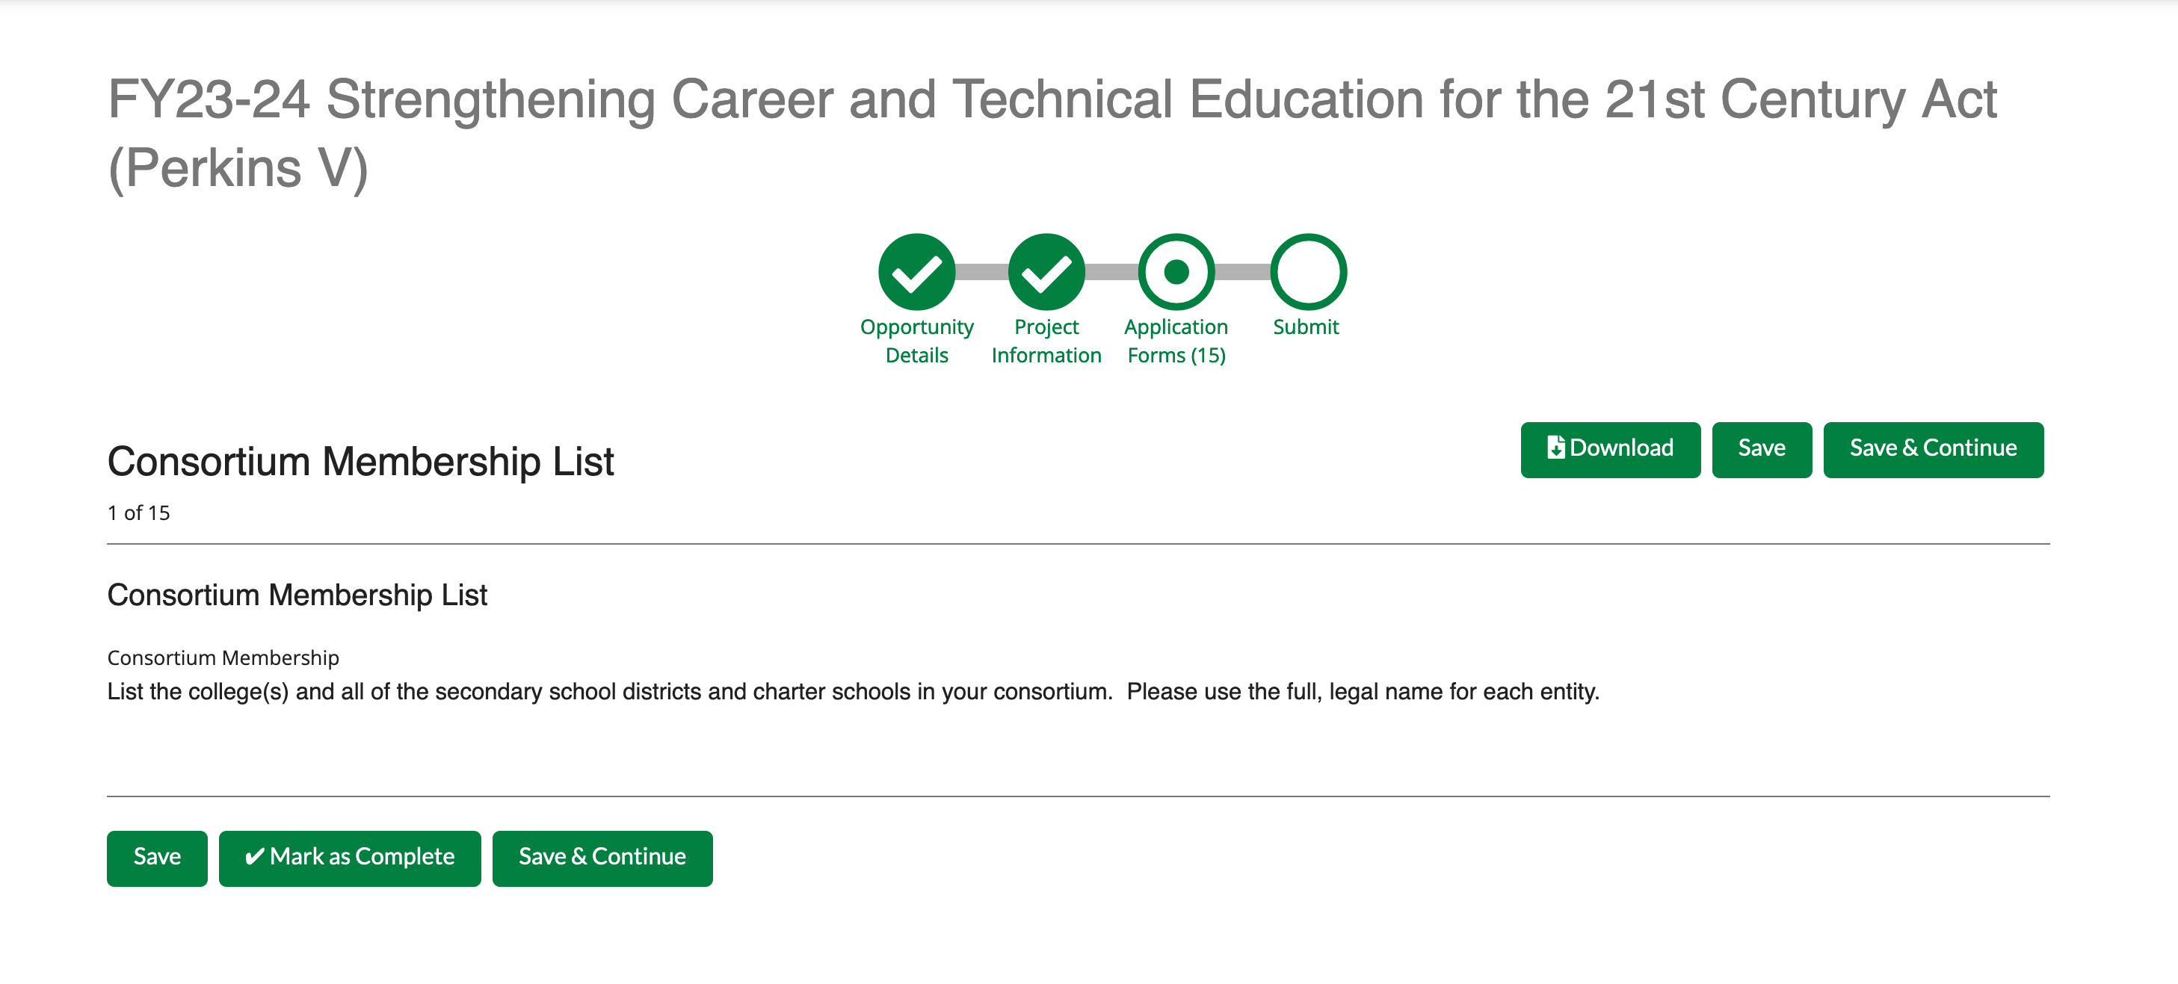

List the college(s) and all of the secondary school districts and charter schools in your consortium. Please use the full, legal name for each entity.

