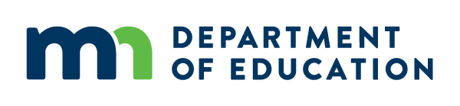


Improvement Plan Template

Directions: Fill out the information below in consultation with the appropriate stakeholder group(s). An improvement plan will need to be submitted annually for each performance indicator on improvement plan status. Be sure to include any context and details that would aid in understanding the circumstances in which the need for improvement is occurring. Once complete, upload this document into the MN Perkins Portal as a required part of your Perkins consortium application for funding.

Consortium:
Performance Indicator:
Planning for Improvement
DATA REVIEW:
Identify the key factors that contributed to missing this performance indicator’s goal. What growth and high need opportunities will be the focus of your improvement plan?
DISPARITIES ANALYSIS:
From the student groups identified as needing focused attention in your gap analysis, which groups will you prioritize to serve and why?
Describe how stakeholders were consulted in the development of the improvement plan. What stakeholder groups were involved?

Directions: Insert more rows in the Action Plan: Current Year and Next Year tables below to include additional Action steps, etc., as needed. Progress on Improvement Plan will be reported in the APR.
Action Plan: Current Year (what will you do right now?)
SDPL (Grant Year):
Actual Performance:
Action Steps: | Stakeholders involved in implementation: | Project Lead (Person responsible for implementing Action Step): | Completion date (by step): | Describe the activities financial resources will be used for:
1.
2.
3.

Action Plan: Next Year (what will you do in the upcoming plan?)
SDPL (Grant Year):
Increase in Actual Performance needed:
Action Steps: | Stakeholders involved in implementation: |  | Project Lead (Person responsible for implementing Action Step): | Completion date (by step): | Describe the activities financial resources will be used for:
1.
2.
3.

