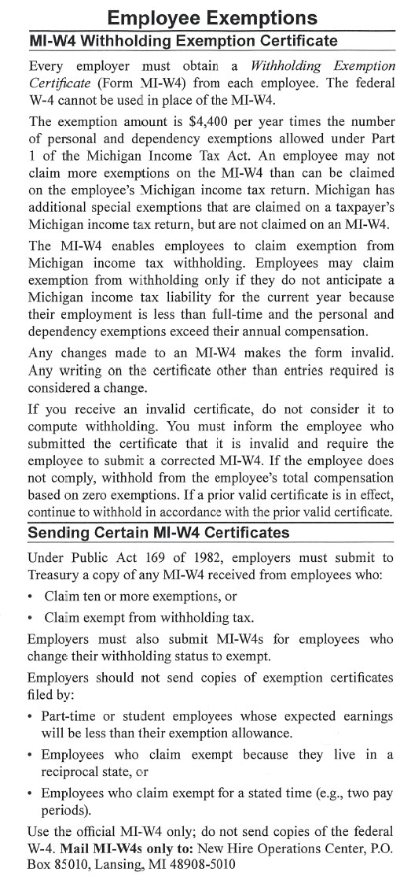
MICHIGAN MI-W4 EMPLOYER INSTRUCTIONS

