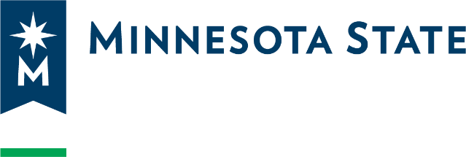

Data Practices Compliance Official Appointment Form
I hereby appoint Click or tap here to enter text.(Name(s)), Click or tap here to enter text.(Title(s)), as Data Practices Compliance Official(s) (DPCO), pursuant to Minnesota Statutes § 13.05, Subd. 13. The DPCO is designated to assist individuals or entities with questions or concerns regarding access to government data or other data practices problems for Click or tap here to enter text.(College/University).
This appointment is continuing until rescinded, or the employee is no longer employed by the College/University whichever is earlier.
President Signature: _______________________________________________
President Name: Click or tap here to enter text.
Date: ______________________________________

c: College/University/Campus DPCO

NOTE: College or university must maintain this document as an official record pursuant to its applicable records retention schedule. Please do not forward copies of this document to the Office of General Counsel.

