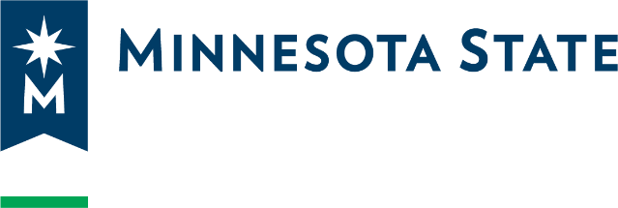

DPCO Contact Information Form
Please e-mail this form to Amanda Bohnhoff (amanda.bohnhoff@minnstate.edu) at the Office of General Counsel.

University or College Name
Click or tap here to enter text.

Data Practices Compliance Official (DPCO)
Name: Click or tap here to enter text.
Title: Click or tap here to enter text.
E-Mail Address: Click or tap here to enter text.
Phone Number: Click or tap here to enter text.

Additional DPCO (if applicable) e.g. student records, employee records, etc.
Name: Click or tap here to enter text.
Title: Click or tap here to enter text.
E-Mail Address: Click or tap here to enter text.
Phone Number: Click or tap here to enter text.

Additional DPCO (if applicable) e.g. student records, employee records, etc.
Name: Click or tap here to enter text.
Title: Click or tap here to enter text.
E-Mail Address: Click or tap here to enter text.
Phone Number: Click or tap here to enter text.

Please provide the following contact information for any follow-up questions that arise:
Name of individual completing this form:Click or tap here to enter text.
Phone:Click or tap here to enter text.
E-mail Address:Click or tap here to enter text.

