How to Claim Your eCard
Full instructions and options for claiming and viewing eCards: https://cpr.heart.org/en/resources/faqs/how-to-claim-and-view-your-aha-ecard
To claim on your phone:
- Scan the QR Code
(or go to https://ecards.heart.org/student/myecards)
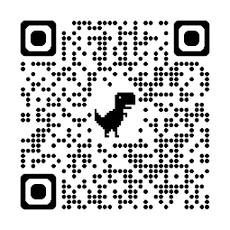
- Enter your first name, last name and email you provided to your instructor, or use your 25-digit eCard code
- Tap ‘Claim’
- Select a security question and enter your answer
- Select to agree to the terms of use, and submit
- Complete the brief survey to rate your AHA class
- View, Download, or Email your new card
If there is a typo on your card, tap the EDIT button at the top right of your card info to request a correction. If you wish to change to a different name or email address, you may be required to contact your instructor so they can verify and submit the change request.
Once you have claimed your eCard, you may access it at any time at https://ecards.heart.org/student/myecards.

