Disability Justice: Why It’s Everybody’s Business

Introductory Session – Disability Justice Workshop series

Disability Justice: Why It’s Everybody’s Business
  - Introductory session – Disability Justice Workshop series
  - January 26th, 2022
  - Rebecca Dosch Brown, Jana Ferguson, Muna Khalif, Katrina Simons

Zoom Navigation – Part One

Zoom Navigation – Part Two

Zoom Navigation – Part Three

Zoom Navigation – Part Four

Land acknowledgment & ICI affirmation of commitment
  - Minnesota State acknowledges the land and the tribal nations upon whose land this work is being accomplished. We acknowledge that we are on Dakota land. We recognize the Native Nations of this region who have called this place home over thousands of years including the Anishinaabe (Ojibwe), Lakota, Nakota, Ho-Chunk, and Cheyenne. We acknowledge the ongoing colonialism and the legacies of violence, displacement, migration, and settlement that foreground the formation of Minnesota State colleges and universities. We commit to advancing critical efforts to understand and address these legacies, including the larger conversation of reparations, repatriation, and redress urgently needed for the scope of ethical acknowledgment to begin in earnest.
  - We affirm our commitment to address systemic racism, ableism, and all other inequalities and forms of oppression to ensure inclusive communities.

Instructional team
  - Rebecca Dosch Brown, dosch018@umn.edu
  - Katrina Simons, simon400@umn.edu
  - Muna Khalif, khali030@umn.edu
  - Jana Hallas Ferguson, jahallas@umn.edu

All are welcome
  - In chat: Type your full name, your campus or affiliation, and one thing you love to do or feel passionate about
  - Take breaks and move as needed: listen to your body

Learning objectives
  - Know what disability is and how common it is
  - Know what ableism is and to recognize it
  - Know disability history and think of how it intersects with histories of race, gender, and class
  - Know some strategies to unlearn ableism

Note about today’s language
  - People use different words to describe disabilities. Not all words are equal, however.

What is disability?
  - A disability is when a person —
    - has a physical or mental impairment that substantially limits one or more major life activities,
    - has a history or record of such an impairment [such as cancer in remission], or
    - is perceived by others as having such an impairment
    - Americans with Disabilities Act, 1990

Limits in one or more major life activities
  - Action
  - Movement
  - Cognitive function
  - Sensory function
  - Task
  - Bodily function

Disability examples
  - Chronic illness
  - Cognitive or Intellectual
  - Developmental
  - Mobility
  - Learning
  - Accident-induced
  - Sensory
  - Mental health
  - Recovery from addiction

World estimate
  - 15% of the world population experiences disability
  - WHO, 2011

USA estimate
  - “Disability Impacts All of Us”
    - 61 million adults in the U.S. have at least 1 disability.
    - 26% or over 1 in 4 adults, has at least one disability in the U.S.
    - 50% of Americans will be diagnosed with a mental illness or mental health disorder in their lifetime.
    - The percentage of people living with disabilities Is highest in the South

Minnesota estimate
  - 1 of 5 adults in MN have a disability, (CDC, 2010)
  - 959,140 adults in Minnesota have a disability
    - This is equal to 22% or 1 in 5 adults in Minnesota

College students with disabilities
  - 19% of U.S. undergraduates
  - 11% of U.S. graduate students
    - (NCES, 2015–16)
  - Minnesota State: 4% of 340,000 registered students

Reasonable accommodations and adaptations
  - Barriers can be:
    - Physical
    - Sensory
    - Attitudinal
    - Systemic

Breakout — Grounding assumptions and rules
  - Be present - however that works for you
  - Turn camera on for breakouts if you can
  - Ensure everyone shares and holds the space together
  - Speak from your experience
  - Everyone is learning. Each journey looks different.
  - Address troubling statements: Focus on the words, not the speaker

Breakout 1 — Exclusion of disability from social justice talk
  - Disability is often excluded when people are talking about equity or social justice work or even about diversity. Why do you think this omission happens so often?
  - Is the word ‘ableism’ new to you? Whether yes or no: Explain what you think the word means.

What is ableism?
  - Ableism is —
    - Oppression, prejudice, stereotyping, or discrimination against disabled people on the basis of actual or perceived disability.
    - A way of thinking and doing that systematically acts as if some people’s abilities, bodies, and minds are less valuable, less worthy, and less desirable than others.
  - Taken and adapted from Lydia X. Z. Brown’s blog, Autistic Hoya

Examples of ableism
  - Words and examples have been modified and adapted
  - from “Naming Ableism” – a poem by Maria Palacios (2017)
  - “You say…….”
    - You assume I will never marry, can’t have children, or be a good parent
    - You say I do not seem disabled, and you mean that as a compliment
    - You say I’m attractive, even though I have a disability
    - You push my wheelchair or pet my service dog without asking permission
    - You use a “baby voice” when you speak to me
    - You set low or zero expectations for me
    - You react to my accommodation request as if it’s a burden for you and not my legal right
    - You tell others I am “cheating” or “lazy” when I ask for an adapted lesson
    - You tell your children to stop staring at me, and you pull them away from me
    - You enjoy films where I’m shown as a monster, a villain, an ‘object of pity,’ or as ‘a joke to laugh at’
    - You use words in everyday conversations like “crazy,” “idiot,” and “stupid”
    - You call the police since I’m “acting funny” by pacing back and forth outside the library
    - You, as a police officer, shoot to kill me after I don’t react to your demands immediately
    - You think I am not worth befriending or dating
    - You sit silently while others bully me about how I look, move, or talk
    - You think I don’t belong in college because I think or act “too differently” from you
    - You see me as a “problem” or as a “distraction” for you and the other students
    - You give praise and extra attention to students who memorize exactly what you said
    - You reward people with a full scholarship even if they might mistreat and bully other people daily
    - You assume, because of my skin color or my accent, that I can’t be as smart as you are
    - You say if I make over one-thousand, three hundred fifty dollars a month, you’ll cancel my access to disability services
    - You say if I get married, my spouse’s income counts toward my income limit to access services, and you’ll cancel my services
    - You legally pay me fifty cents an hour to work a job where everyone else gets minimum wage.
    - In fact, you get tax relief for hiring and paying me sub-minimum wages.
    - You feel sorry for me
    - You say you’d rather die than be like me
    - You’re always trying to heal me or fix me, even when I tell you I like how I am
    - You can’t imagine why I might love myself, my body, and my brain, just as it is.
    - Some examples are directly taken or modified from Maria Palacios, Naming Ableism poem

Break time - 5 minutes

Disability History 101
  - 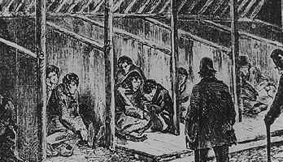
  - 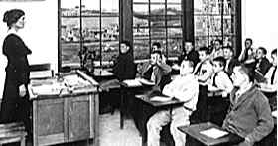
  - 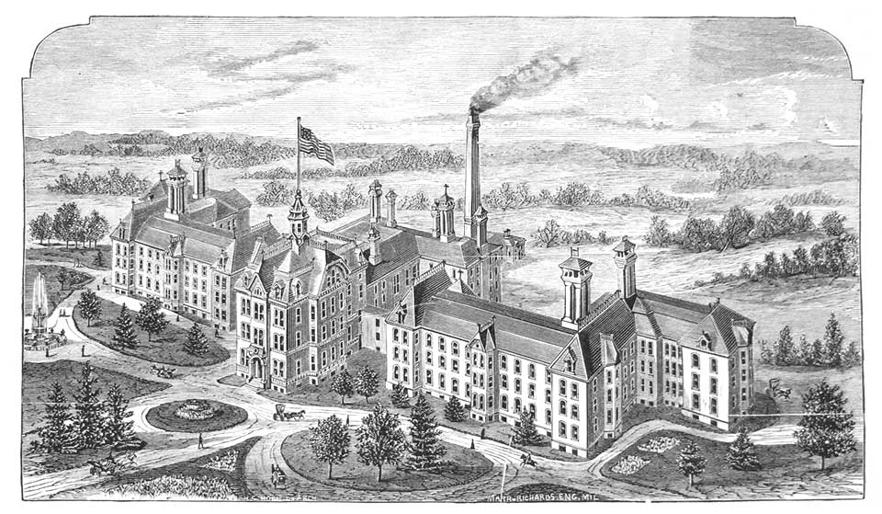

Industrialization
  - Moving workers from farms to factories
  - Certain bodies and minds did not “fit” into the factory standard for a “worker”
  - 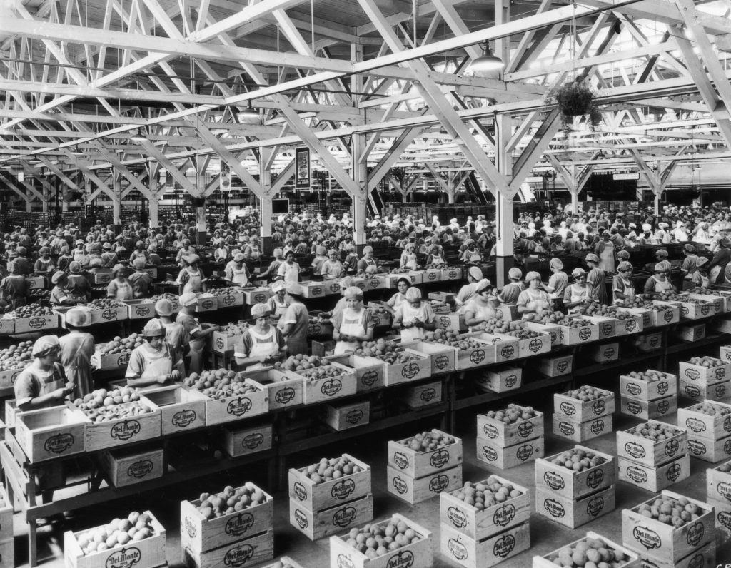

Intelligence test – Binet
  - 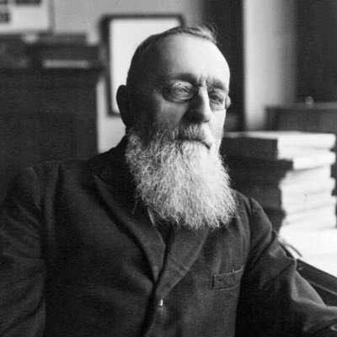

Binet’s rules
  - The scores do not define anything permanent.
  - The scale is a rough guide for identifying and helping children. It is not a way of measuring children’s worth.
  - Low scores do not mean a child cannot learn.
  - Source: Parallels in Time

IQ tests and U.S. eugenics
  - Goddard was one of many who argued that low scores demanded the
    - Passing of forced sterilization laws
    - Building more institutions to segregate people with low IQ scores from society
  - Source: Parallels in Time
  - 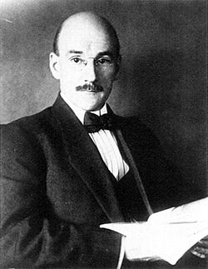

Buck v. Bell case
  - 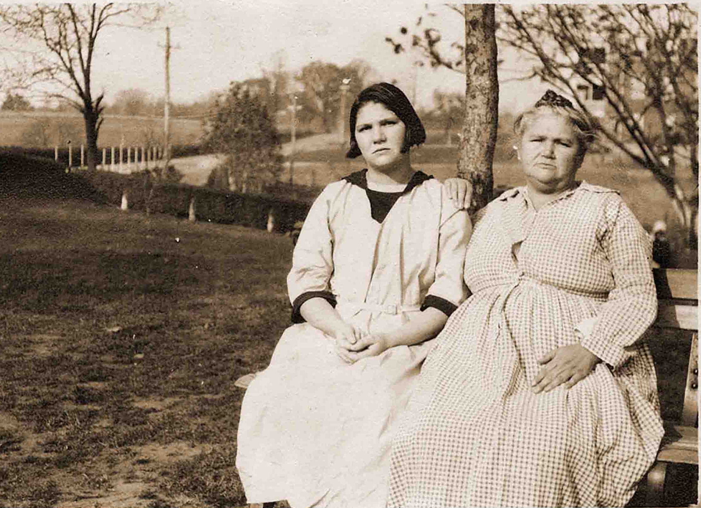

Nazi Germany’s T4 project
  - Source: Parallels in Time
  - 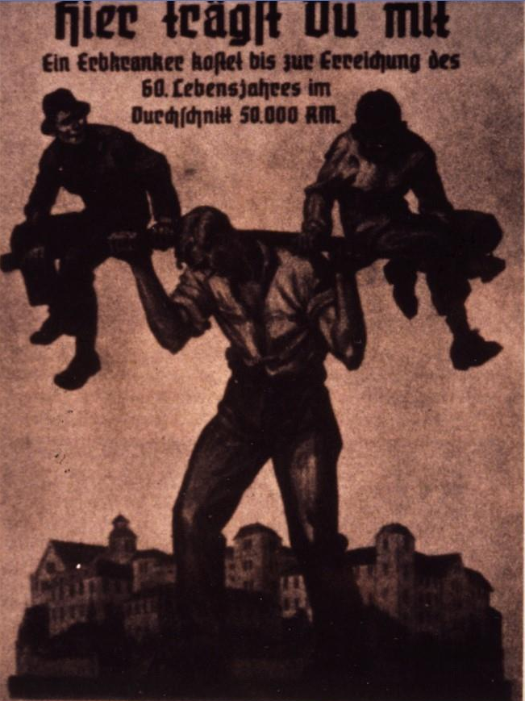

Institutionalization
  - “Children were warehoused at Willowbrook, left unattended on filthy wards.”
  - 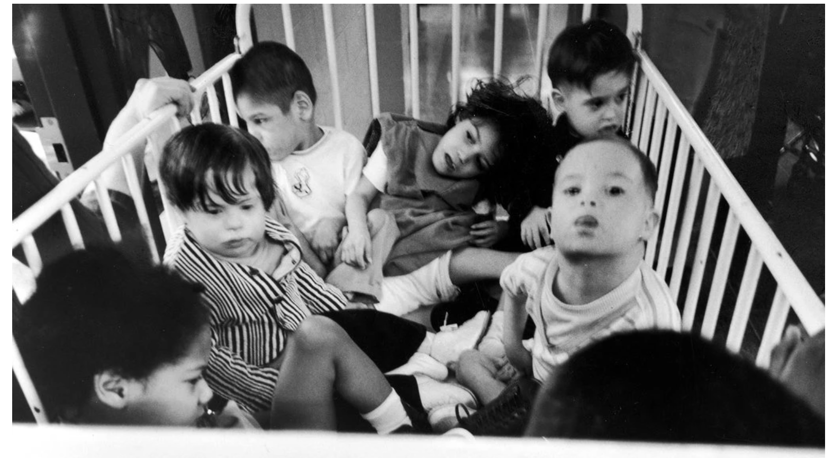

Willowbrook: The Last Great Disgrace
  - Willowbrook: The Last Great Disgrace video trailer
    - Trigger warning: This video has nudity and signs of severe neglect.

Judy Moiseff, Willowbrook survivor
  - My Willowbrook Experience video

Breakout 2 — Reflect on disability
  - What did you learn about disability and ableism today that you will not forget? Explain why.

Actions we can all take
  - Learn more disability history and its intersections
  - Notice and set aside assumptions about disability; slow down “short-cuts”
  - Question why things are the way they are: Who benefits? Who’s excluded?
  - Learn directly from many different people with disabilities
  - Challenge ableist systems in collaboration with disabled leaders
  - Join us for the four upcoming Disability Justice sessions

Disability Justice workshop series
  - Disability Justice: Why It’s Everybody’s Business – Jan 26
  - Racial Justice & Disability Justice: Working Together to Free Our Minds & Bodies – Feb 23
  - New Ways to Talk About Disability – Mar 30
  - Experience Is Our Teacher: People with Disabilities on Allyship, Advocacy, & Pride – April 27
  - From Vision to Action: Lets’ Create Inclusive Classrooms, Campuses & Communities – May 4

Grace Lee Boggs (1915–2015)
  - “You cannot change any society unless you take responsibility for it, unless you see yourself as belonging to it and responsible for changing it.”
  - 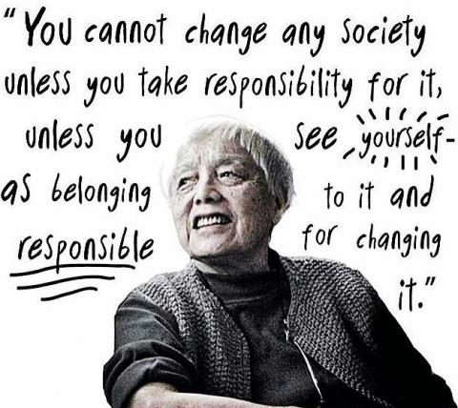

Further resources
  - Baynton, D. (2001). Disability and the justification of inequality in American history. In P.K. Longmore & L. Umansky (eds.), The new disability history. New York University Press.
  - Brown, L.X.Z. Briefly Abled Privilege Checklist.
  - Kim, S. (2021). Marriage Penalty Prevents Marriage Equity for People with Disabilities. WID.org.
  - Parallels in Time: MN Governor’s Council on Developmental Disabilities
  - Wong, A. Disability Visibility Project
  - Ben-Moshe, L. Decarcerating Disability
  - “Crip Camp” film
  - Disability Culture Rap
  - Maria Palacios’s poem, Naming Ableism

Accessible handout

Thank you

