Racial Justice & Disability Justice: Working Together to Free Our Minds and Bodies

Session #2 – Disability Justice Workshop series

Disability Justice: Why It’s Everybody’s Business
  - Introductory session – Disability Justice Workshop series
  - February 23rd, 2022
  - Rebecca Dosch Brown, Jana Ferguson, Muna Khalif, Katrina Simons

Land acknowledgment & ICI affirmation of commitment
- Minnesota State acknowledges the land and the tribal nations upon whose land this work is being accomplished. We acknowledge that we are on Dakota land. We recognize the Native Nations of this region who have called this place home over thousands of years including the Anishinaabe (Ojibwe), Lakota, Nakota, Ho-Chunk, and Cheyenne. We acknowledge the ongoing colonialism and the legacies of violence, displacement, migration, and settlement that foreground the formation of Minnesota State colleges and universities. We commit to advancing critical efforts to understand and address these legacies, including the larger conversation of reparations, repatriation, and redress urgently needed for the scope of ethical acknowledgment to begin in earnest.
- We affirm our commitment to address systemic racism, ableism, and all other inequalities and forms of oppression to ensure inclusive communities.

Instructional team
- Rebecca Dosch Brown, dosch018@umn.edu
- Katrina Simons, simon400@umn.edu
- Muna Khalif, khali030@umn.edu
- Jana Hallas Ferguson, jahallas@umn.edu

All are welcome
- In chat: Type your full name, your campus or affiliation, and one thing you love to do or feel passionate about
- Take breaks and move as needed: listen to your body

Learning Objectives
  - Know systems deliver greatest injustices at the intersection of multiple minoritized identities
  - Name and spot common detours away from our equity and justice work
  - Reflect on ideas of racial and disability justice
  - Chart your own growth as advocate and ally

Intersectionality
- “A lens, a prism, for seeing the way in which various forms of inequality often operate together and exacerbate each other.” Kimberlee Crenshaw, 1989
- 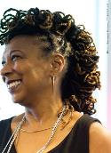

Intersectionality – Race and Disability
  - Video of Keri Gray speaking about the intersectionality of race and disability.

Ableism and Racism: Roots from the same tree – clip #1
  - Be Antiracist Podcast

Ableism and Racism: Roots from the same tree – clip #2
- Be Antiracist Podcast

TL Lewis’s definition of ableism
- Ableism is a system of assigning value to people's bodies and minds based on societally constructed ideas of normalcy, productivity, desirability, intelligence, excellence, and fitness. These constructed ideas are deeply rooted in eugenics, anti-Blackness, misogyny, colonialism, imperialism, and capitalism. This systemic oppression that leads to people and society determining people's value based on their culture, age, language, appearance, religion, birth or living place, "health/wellness", and/or their ability to satisfactorily re/produce, "excel" and "behave." You do not have to be disabled to experience ableism.
    - Working definition by @TalilaLewis, updated January 2022, developed in community with disabled Black/negatively racialized folk, especially @NotThreeFifths.

Disability undergirds “-ist” beliefs
- "Ableism is connected to all our struggles because it undergirds notions of whose bodies and minds* are considered valuable, desirable and disposable." Mia Mingus, disability justice advocate.
- Quote adapted by R. Dosch Brown

Poverty rates of working-age population by race, ethnicity and disability, 2018
- 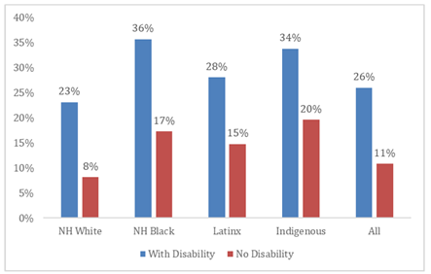
- Data source: NDI analysis of U.S. Census Bureau, 2019

Police killings: Intersect of racism and ableism
- 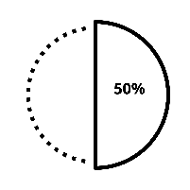
    - SOURCE: Ruderman Family Foundation, 2018; Schwartz & Jahn, 2020.
- 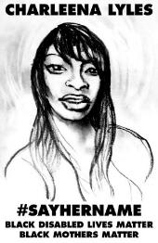

Racial and Disability Equity Detours
- “Actions and approaches [that organizations]…adopt in the name of equity that might create the illusion of equity progress, but that do not cultivate more equity. “
    - Detours may be adopted based on misunderstandings about what equity means or the level of transformation needed to achieve equity.
    - Detours may be adopted purposefully to avoid more meaningful equity work.
- Language adapted by R. Dosch Brown to include disability detours.
- Source: Gorski, P. (2019). Avoiding racial equity detours. Educational Leadership, 76(6), 56-61.

Equity Detours 1,2, and 3
- Pacing for privilege
- Deficit ideology
- Celebrating diversity
- Language adapted by R. Dosch Brown to include disability detours.
- Source: Gorski, P. (2019). Avoiding racial equity detours. Educational Leadership, 76(6), 56-61.

Equity Detours 4,5, and 6
- Shiny new program
- “Culture” & “Special Needs”
- Individualizing racism and ableism
- Language adapted by R. Dosch Brown to include disability detours.
- Source: Gorski, P. (2019). Avoiding racial equity detours. Educational Leadership, 76(6), 56-61.

Breakout instructions
  - Click on the blue “Join” button that should appear on your screen
  - Switch to Group 1 for ASL interpretation or live captioning
  - No more than 5-6 people per room, please

Breakout: Grounding assumptions
  - Be present — however that works for you
  - Turn on your camera, if you can
  - Ensure everyone shares and holds the space together
  - Speak from your own experience and ideas
  - Everyone is learning. Each journey looks different
  - Address troubling statements: Focus on the words, not the speaker

Breakout: What’s the systemic problem(s)?
  - A college search committee concludes no qualified IBPOC applicant exists for the “Cultural Diversity Asst. Director” job. They hire the senior member’s nephew, who is white and from Yale, since he did Peace Corps for a year.
  - Disabled & IBPOC college students finish degrees less than white, non-disabled students. To fix this, the college assigns non-credit classes to improve these students’ study skills in their first year.
  - A university spent $20,000 to bring the movie director Tyler Perry in to talk about restorative justice in barbershops for Black History Month.
  - Bonus point, if time: Which detour types do you spot above?

Stretch & Break time

Intersectional justice in action: 504 sit-in
- 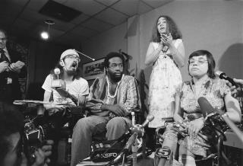.

“My body doesn’t oppress me, society does.” Patty Berne and Stacy Milgren
- Video: My Body Doesn’t Oppress Me, Society Does

Disability justice leaders today
- 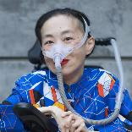
- 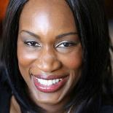
- 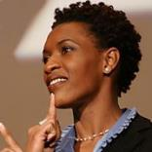
- 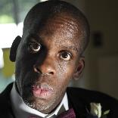
- 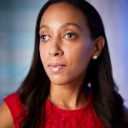

10 Principles for disability justice
- Intersectionality
- Leadership of Those Most Impacted
- Anti-Capitalist Politic
- Cross-Movement Solidarity
- Recognizing Wholeness
- Sustainability
- Commitment to Cross-Disability Solidarity
- Interdependence
- Collective Access
- Collective Liberation
- Source: Berne, P., et al, 2018

Reflection tool: Becoming anti-racist and anti-ableist
- 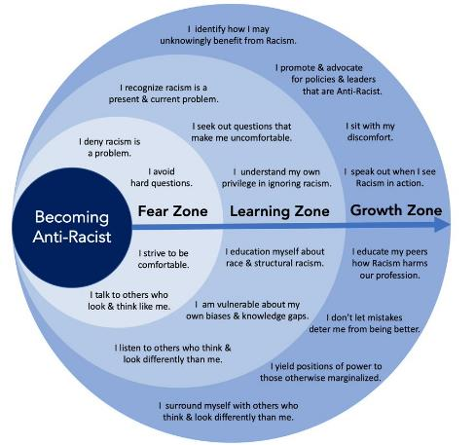
- Adapted from @AndrewMIbrahim

Next steps
- Learn from past and current leaders from multiple minoritized communities, such as those shared with you today
- Never assume one person’s experience, voice, and opinion counts for an entire community or group of people
- Scrutinize systems (not victims) for racist/ableist disproportionalities
- Spot it and name it if you face any racial and disability detours

Disability Justice workshop series
- Disability Justice: Why It’s Everybody’s Business – Jan 26
- Racial Justice & Disability Justice: Working Together to Free Our Minds & Bodies – Feb 23
- New Ways to Talk About Disability – Mar 30
- Experience Is Our Teacher: People with Disabilities on Allyship, Advocacy, & Pride – April 27
- From Vision to Action: Lets’ Create Inclusive Classrooms, Campuses & Communities – May 4

Further resources
- Kimberlé Crenshaw, “Demarginalizing the Intersection of Race and Sex: A Black Feminist Critique of Antidiscrimination Doctrine, Feminist Critique of Antidiscrimination Doctrine, Feminist Theory and Antiracist Politics,” University of Chicago Legal Forum, 1989, no. 1 (1989): 139-167.
- MNLEND Fellowship: A paid fellowship training on neurodevelopmental disabilities. Applications close March 15 to join the next 2022-23 year.
- Ten Principles of Disability Justice by P. Berne, et al.
- Disability Visibility Network – an online community dedicated to creating, sharing, and amplifying disability media and culture.
- Disability Visibility: First-Person Stories from the Twenty-First Century, Edited by Alice Wong
- The Pretty One: On Life, Pop Culture, Disability, and Other Reasons to Fall in Love with Me, by Keah Brown
- Haben: The Deafblind Woman Who Conquered Harvard Law, by Haben Girma
- The Harriett Tubman Collective – A Collective of Black Deaf & Black Disabled organizers, community builders, activists, dreamers, lovers striving for radical inclusion and collective liberation.
- How do you sign ‘Black Lives Matter’ in ASL?, LA Times
- Nothing About Us Without Us: Disability Oppression and Empowerment, by James I. Charlton
- Schacter, D. & Addis, D. (2007). The cognitive neuroscience of constructive memory: remembering the past and imagining the future. Phil. Trans. R. Soc.
- Sins Invalid. (2019). Skin, Tooth, and Bone: The Basis of Movement is Our People (2nd ed.). sinsinvalid.org.
- “What Your Disabled Friends Want You To Know About 'Going Back To Normal' Post-Vaccine,” Huffington Post

Accessible handout of PowerPoint and recording
- Will be made available at MN State Equity 2030 website

Thank you

Additional data on race & disability disproportionality

IBPOC children – Maltreatment type risk
- Minnesota child protection agencies received 85,917 reports of child maltreatment, almost no change from 2018.
- American Indian children were about five times more likely to be involved in completed maltreatment assessments/investigations than white children, while children with two or more races and African-American children were both approximately three times more likely to be involved
- Oversurveillance of Black, Brown, and disabled families possible factor, per disproportionate out-of-home placements (next slides)

Disabled children – Maltreatment type risk
- Disabled children were at least 3x more likely to be maltreated than children without disabilities
- 3.8x higher risk for neglect
- 3.1x higher risk for sexual abuse
- 3.8x higher risk for physical abuse
- 3.9x higher risk for emotional abuse
- Disabled children were victims of more serious physical injury and more frequent and severe sexual offenses

Children – Out of home placement disproportionality
- American Indian children were 16.8 times more likely,
- African-American children were 2.6 times more likely, and
- Children identified as two or more races were 5.8 times more likely than white children to experience out-of-home placement based on Minnesota population estimates from 2018
- Nearly 40% (38.58%) of kids in out of home placement have an identified disability
- Source: Minnesota’s Out-of-Home Care and Permanency Report 2019; Children with Disabilities Involved in the Child Welfare Continuum: Minnesota Department of Human Services, 2015

Disabled children out of home placement
- Children with disabilities are
    - more often subsequently placed in foster care
    - 46% less likely to exit foster care
    - 48% less likely to return to birth parents
- Source: Legano et al., 2021; Slayter, 2016

IBPOC children out of home placement
- There were 15,297 children out-of-home placement episodes who experienced one or more days in out-of-home care.
- American Indian children were 16.8 times more likely,
- African-American children were more than 2.6 times more likely, and
- Children identified as two or more races were 5.8 times more likely than white children to experience out-of-home care, based on Minnesota population estimates from 2018.
- Source: Minnesota’s Out-of-Home Care and Permanency Report 2019

Physical restraint in schools – by disability
- 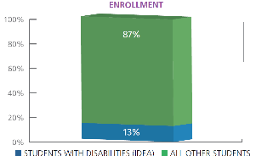
- 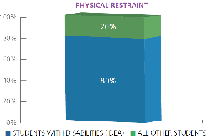
- Source: U.S. Department of Education, Office for Civil Rights

Pre-school expulsions – race and disability
- Black pre-school students were expelled at rates that were more than 2 times their share (or 38.2%) of their total pre-school enrollment rate (18.2%).
- Pre-school disabled students under IDEA were expelled at rates more than 2.5 times their share (or 56.9%) of their total pre-school enrollment (22.7%).
- Source: U.S. Department of Education, Office for Civil Rights, 201718 data (2019)

Out-of-school suspensions
- Disabled students under IDEA represented 13.2% of total student enrollment but received 20.5% of one or more in-school suspensions and 24.5% of one or more out-of-school suspensions.
- Black disabled students under IDEA accounted for 2.3% of total student enrollment but received 6.2% of one or more in-school suspensions and 8.8% of one or more out-of-school suspensions.
- Source: Source: U.S. Education Department, Office for Civil Rights, Civil Rights Data Collection, 2017-18 State and National Estimations, released June 2021.

Forced sterilization
- 70,000+ disabled people (1905-1981)
- 150,000+ women in poverty and/or IBPOC
- Today women in prisons, immigration detention centers, and disabled women under guardianship still can face sterilization

Disabled people in prisons
- 