New Ways to Talk About Disability

Session #3 – Disability Justice Workshop series

New Ways to Talk About Disability
  - March 30, 2022, 10:00 a.m. - 11:00 a.m.
  - Rebecca Dosch Brown, Muna Khalif, Katrina Simons

Land acknowledgment & ICI affirmation of commitment
- Minnesota State acknowledges the land and the tribal nations upon whose land this work is being accomplished. We acknowledge that we are on Dakota land. We recognize the Native Nations of this region who have called this place home over thousands of years including the Anishinaabe (Ojibwe), Lakota, Nakota, Ho-Chunk, and Cheyenne. We acknowledge the ongoing colonialism and the legacies of violence, displacement, migration, and settlement that foreground the formation of Minnesota State colleges and universities. We commit to advancing critical efforts to understand and address these legacies, including the larger conversation of reparations, repatriation, and redress urgently needed for the scope of ethical acknowledgment to begin in earnest.
- We affirm our commitment to address systemic racism, ableism, and all other inequalities and forms of oppression to ensure inclusive communities.

Instructional team
- Rebecca Dosch Brown, dosch018@umn.edu
- Katrina Simons, simon400@umn.edu
- Muna Khalif, khali030@umn.edu
- Jana Hallas Ferguson, jahallas@umn.edu

All are welcome
- In chat: Type your full name, your campus or affiliation, and your favorite food or meal
- Take breaks and move as needed: listen to your body

Learning Objectives
  - Know the differences between person-first language and identity-first language
  - Learn honor whatever language the disabled person or disabled community prefers
  - Learn key disability models that frame how society views and talks about disability
  - Adopt strategies to move away from offensive and harmful language toward inclusive language

Video – Moira Ann Rossi on the ‘R’ Word
- Video of Moira Ann Rossi speaking about the ‘R’ word.

People First vs. Identity First Language
  - 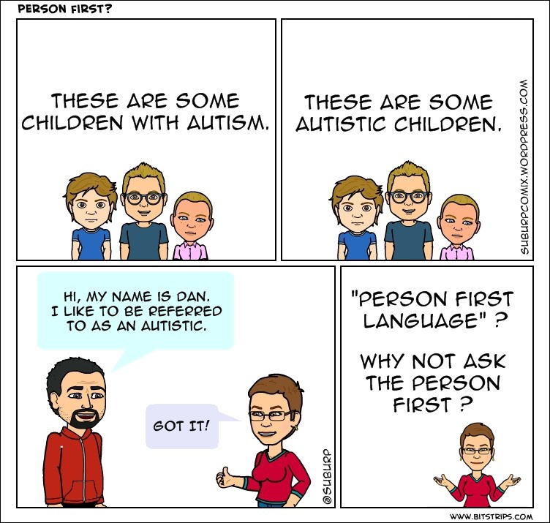

When in doubt…
  - 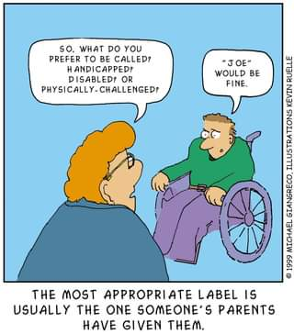

Video – Awkward No More
- Video: Awkward No More

Chat 1 – Why so Awkward?
- What social conditions or systems might create the awkwardness non-disabled people often have about disability?

Euphemisms
- . 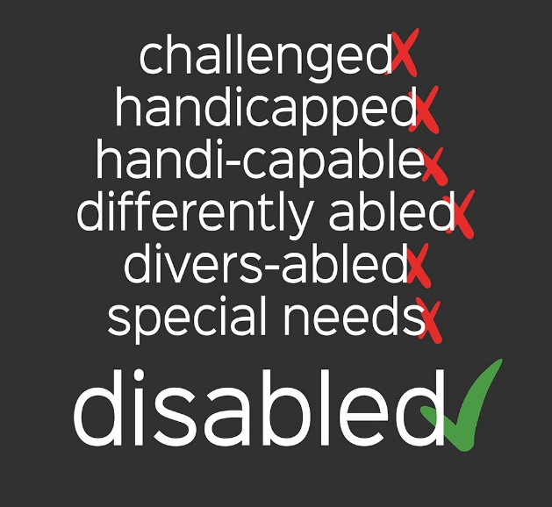
- Source: neurowonderful tumblr

Four Common Disability Models
- Charity/pity
- Medical
- Social
- Justice

Charity/Pity Model
- 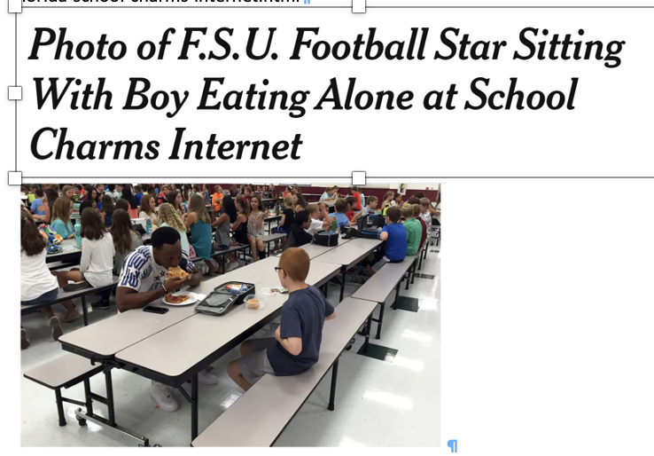
- Source: Michael Halligan, Associated Press

Video – Medical Model vs. Social Model
- Video: Social Model of Disability

Disability Justice Model
- 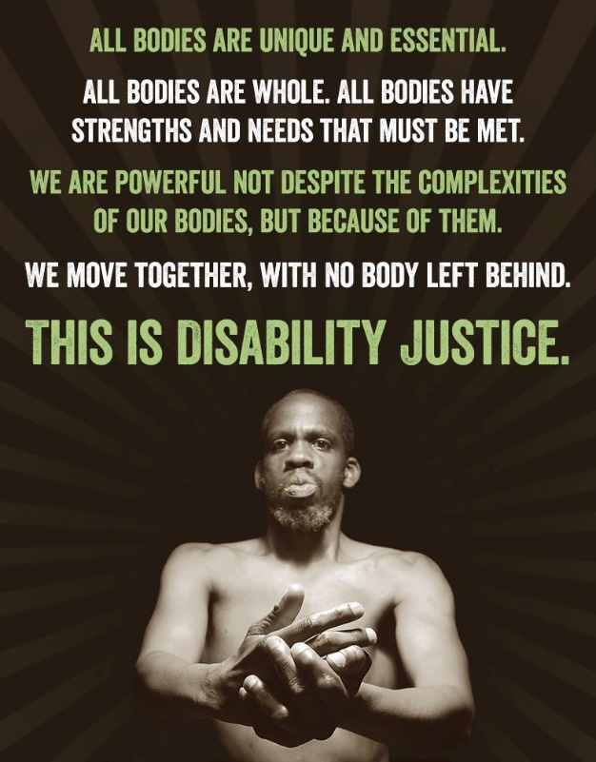

Video – “I’m not here to inspire you” – Stella Young
- Video: I’m not here to inspire you, thank you very much

Chat – Reaction to Stella’s Talk
  - What did Stella say that will stay with you from here onward?

Five Tips for Talking About Disability
  - Accept that disability is a natural part of the human experience
  - Start noticing ableist language that you and other people use
  - Use words that do not diminish, infantilize, stereotype, or dehumanize people
  - Ask the person and respect their language preferences
  - If you ever make a mistake, apologize, learn from it, and do better next time

Disability Justice workshop series
- Disability Justice: Why It’s Everybody’s Business – Wednesday, January 25
- Racial Justice & Disability Justice: Working Together to Free Our Minds & Bodies – Wednesday, February 23
- New Ways to Talk About Disability – Wednesday, March 30
- Experience Is Our Teacher: People with Disabilities on Allyship, Advocacy, & Pride – Wednesday, April 27
- From Vision to Action: Lets’ Create Inclusive Classrooms, Campuses & Communities – Wednesday, May 4

Further resources
  - MNLEND Fellowship: If interested in a paid year-long interdisciplinary fellowship training about neurodevelopmental disabilities and disability policy: lend.umn.edu. Applications reopens in Oct 2022 for the 2023-24 cohort.
  - How to Treat a Person with Disabilities, According to People with Disabilities- full video
  - I’m not your inspiration, thank you very much – Stella Young’s full video
  - Disability microaggression everyday examples from WSU, Vancouver
  - Emily Landau’s book

Accessible handout of PowerPoint and recording
- Will be made available at MN State Equity 2030 website

Thank you

