Experience Is Our Teacher: People with Disabilities on Allyship, Advocacy, and Pride

Session #4 – Disability Justice Workshop series

New Ways to Talk About Disability
  - April 27, 2022, 10:00 a.m. - 11:00 a.m.
  - Rebecca Dosch Brown, Muna Khalif, Katrina Simons, Jana Ferguson

Land acknowledgment & ICI affirmation of commitment
- Minnesota State acknowledges the land and the tribal nations upon whose land this work is being accomplished. We acknowledge that we are on Dakota land. We recognize the Native Nations of this region who have called this place home over thousands of years including the Anishinaabe (Ojibwe), Lakota, Nakota, Ho-Chunk, and Cheyenne. We acknowledge the ongoing colonialism and the legacies of violence, displacement, migration, and settlement that foreground the formation of Minnesota State colleges and universities. We commit to advancing critical efforts to understand and address these legacies, including the larger conversation of reparations, repatriation, and redress urgently needed for the scope of ethical acknowledgment to begin in earnest.
- We affirm our commitment to address systemic racism, ableism, and all other inequalities and forms of oppression to ensure inclusive communities.

Instructional team
- Rebecca Dosch Brown, dosch018@umn.edu
- Katrina Simons, simon400@umn.edu
- Muna Khalif, khali030@umn.edu
- Jana Hallas Ferguson, jahallas@umn.edu

All are welcome
- In chat: Type your full name, your campus or affiliation, and who your favorite person is and why.
- Take breaks and move as needed: listen to your body

Learning Objectives

Reflect on their own complex identities

Know disability identity and pride is as complex and multi-faceted

Learn to support disability allyship and advocacy

Understand difference between empathy and compassion

Know privileges and use them to fight for justice

Chat – What makes you you?

What’s the identity or label people likely assign you when they first look at you? Type one word

List at least 2 or 3 more identities you have

Examples: student, teacher, parent, child, sibling, pacifist, activist, gamer, introvert, extrovert, lover, bookworm, athlete, poet, artist, comedian, traveler, refugee, dancer, nature-lover, musician, survivor, mechanic, gardener, friend, singer, fighter, immigrant, foodie, risk-taker

Identity – ‘Disability is Not One Thing’
  - Video: M State Student Voice Project

John Smith – Not Easy Life
  - Video: John Smith – Not Easy Life

Advocacy
- Self-advocacy
- Peer advocacy
- Systems advocacy

Self Advocacy

Learning, practicing, and taking action, over and over

Know yourself

Know your wants, needs, and rights

Know who your allies are

Know how to get what you need

Euphemisms

Ricardo Thorton - Growth
- Video: Ricardo Thorton - Growth

Max Barrows – Strong Bonds
- Video: Max Barrows – Building Bonds

I Do, We Do, You Do
- 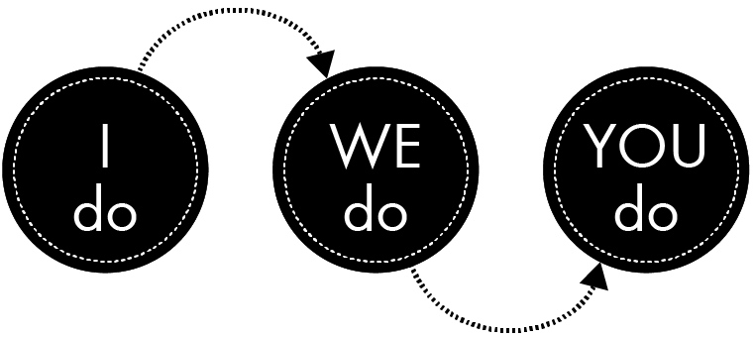

Breakout Instructions
- Click on the blue “Join” button that should appear on your screen
- Switch to Group 1 for ASL interpretation or live captioning
- No more than 4 people per room, please

Breakout grounding assumptions

Be present — however that works for you

Turn on your camera, if you can

Ensure everyone shares and holds space together

Speak from your own experience and ideas

Everyone is learning. Each journey looks different. Be kind.

Five Tips for Talking About Disability

Breakout – Reflection
- Tell about a time you acted as self-advocate, peer advocate or systems advocate for any cause
- Did you make mistakes, find allies, and/or learn anything?

Wheel of Privilege
- 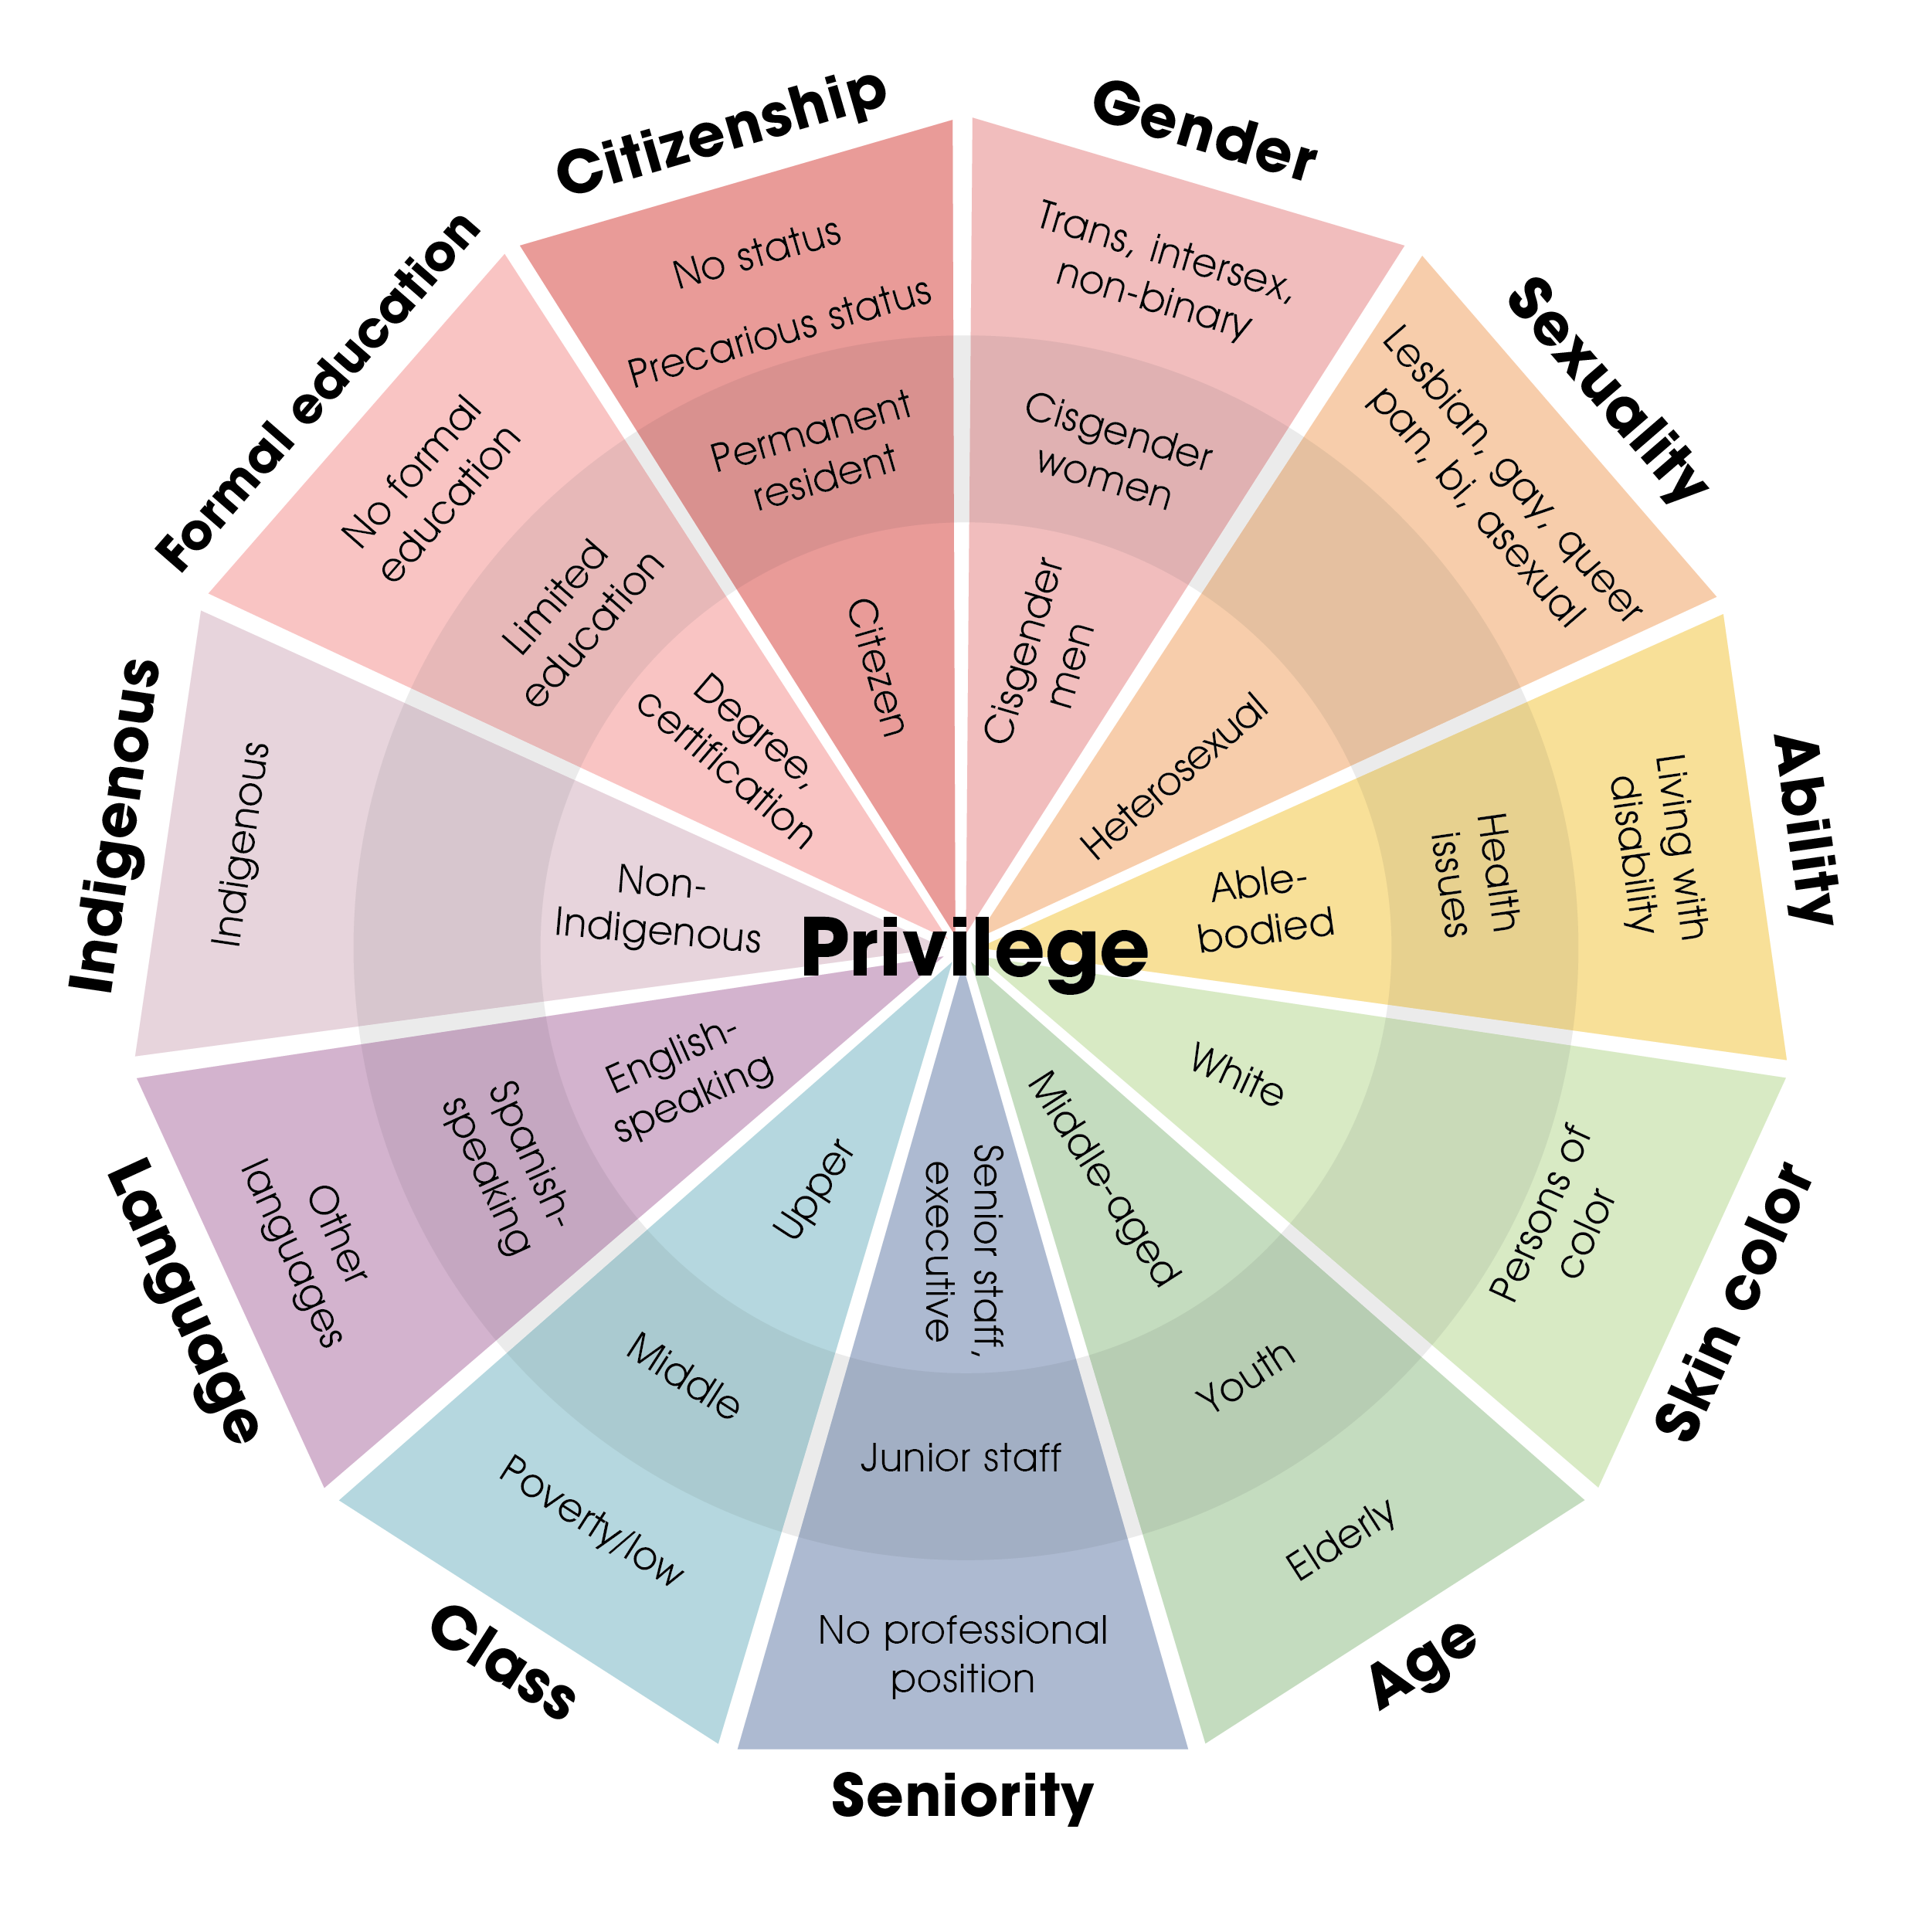
- Source: Adapted from CCR

Ally
- A – Always center the impacted
- L – Listen and learn from those who live in oppression
- L – Leverage your privilege
- Y – Yield the floor

Empathy versus Compassion
- 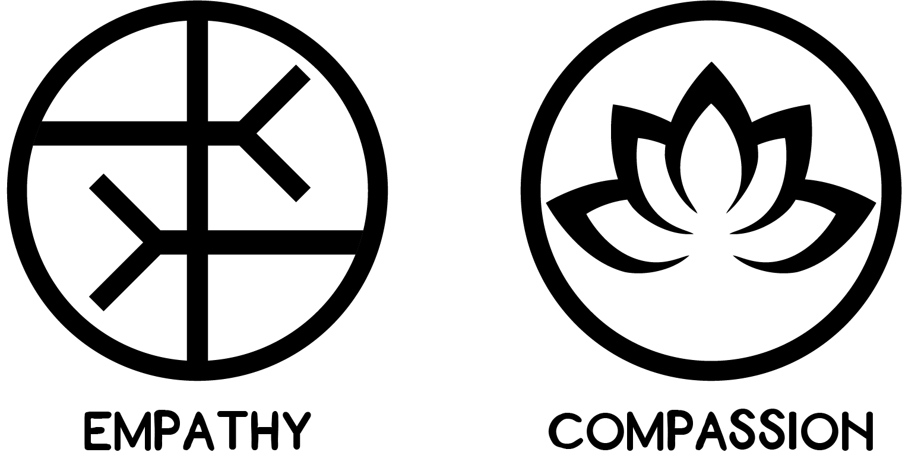

Champions of Inclusion
- Champions of inclusion CONNECT with disabled students as people who are seen and valued as contributors.
- Champions of inclusion COMMUNICATE enthusiasm and act comfortably around disabled people.
- Champions of inclusion CHALLENGE disabled students to work their best toward high standards.
- Champions of inclusion CREATIVELY ADAPT and UTILIZE appropriate strategies and materials to help disabled students learn and succeed.
- Champions of inclusion COLLABORATE with students and others to maximize students’ development.

Take away
- What’s one take-away that you will keep or use from today?

Disability justice workshop series
- Disability Justice: Why It’s Everybody’s Business – Jan 26
- Racial Justice & Disability Justice: Working Together to Free Our Minds & Bodies – Feb 23
- New Ways to Talk About Disability – March 30
- Experience Is Our Teacher: People with Disabilities on Allyship, Advocacy, & Pride – April 27
- From Vision to Action: Let’s Create Inclusive Classrooms, Campuses & Communities – May 4

Further resources
- MNLEND Paid Leadership Fellowship on neurodevelopmental disabilities and policy change
- [Application reopens in Oct 2021 for the 2022-23 cohort].
- Student Voices videos (Need MN State affiliation to access)
- MN Inclusive Higher Education Consortium (MIHEC)
- Black, Disabled, and Proud: COLLEGE STUDENTS WITH DISABILITIES
- National Center for College Students with Disabilities
- THINK College -Center for inclusive college for students with intellectual disabilities
- Green Mountain Self Advocates (co-led by Max Barrows featured in slides above)
- Self-Advocacy Online (SAO)
- Association of Higher Education & Disabilities (AHEAD, National) + MN AHEAD Chapter
- Autistic Self Advocacy Network (ASAN) - Empowering Leadership Guide
- ACLU Disability Rights
- Accessible handout and recording of today’s session (will be posted within a week)

Thank you

