From Vision to Action: Let’s Create Inclusive Classrooms, Campuses and Communities

Session #5 – MN State Disability Justice Workshop series

New Ways to Talk About Disability
a. 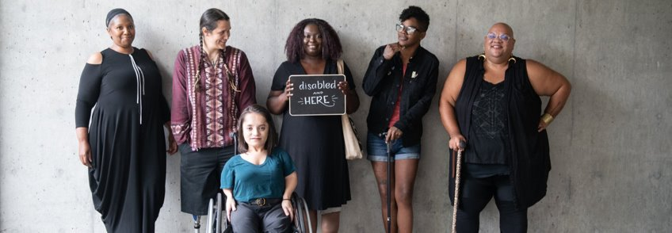
b. May 4, 2022, 10:00 a.m. - 11:00 a.m.
c. Rebecca Dosch Brown, Katrina Simons, and Jana Ferguson

Land acknowledgment & ICI affirmation of commitment
- Minnesota State acknowledges the land and the tribal nations upon whose land this work is being accomplished. We acknowledge that we are on Dakota land. We recognize the Native Nations of this region who have called this place home over thousands of years including the Anishinaabe (Ojibwe), Lakota, Nakota, Ho-Chunk, and Cheyenne. We acknowledge the ongoing colonialism and the legacies of violence, displacement, migration, and settlement that foreground the formation of Minnesota State colleges and universities. We commit to advancing critical efforts to understand and address these legacies, including the larger conversation of reparations, repatriation, and redress urgently needed for the scope of ethical acknowledgment to begin in earnest.
- At the Institute on Community Integration at The University of MN, we affirm our commitment to address systemic racism, ableism, and all other inequalities and forms of oppression to ensure inclusive communities.

Instructional team
- Rebecca Dosch Brown, dosch018@umn.edu
- Katrina Simons, simon400@umn.edu
- Muna Khalif, khali030@umn.edu (not co-facilitating for today)
- Jana Hallas Ferguson, jahallas@umn.edu

All are welcome
- In chat: Type your full name, your campus or affiliation, and tell us your favorite word and why
- Take breaks and move as needed: listen to your body

Learning Objectives

Know that ableism is vs. what meaningful inclusion is

Learn that Person-Centered Thinking and Human Centered Design can be equity and justice tools

Practice designing for inclusivity

Get courage to take action for disability justice

What is ableism again?

Oppression, prejudice, stereotyping, or discrimination against disabled people on the basis of actual or presumed disability.

A way of thinking and doing that systematically acts as if some people’s abilities, bodies, and minds are less valuable, less worthy, and less desirable than others.

Source: Adapted from Lydia X. Z. Brown

Meaningful (or radical) inclusion
  - Meaningful or radical inclusion means that all learners are valued and provided a flexible, optimal learning environment intentionally undoing past harms, and providing the right support for college success.

Inclusive education - Naieer
  - Video: Intelligent Lives Preview

Barriers to higher education
- Physical
- Sensory
- Attitudinal
- Systemic

Opening Doors to College

Video: Opening Doors to College Film

Tools for more inclusive design
- Person Centered Thinking
- Human Centered Design

Person-Centered Thinking

Asking and or carefully observing what’s working for the students

What is important FOR each of them as a learner?

Accommodations, adaptations, environment

What is important TO each of them as a learner?

Human-Centered Design
- Humility
- Radical collaboration
- Rapid prototyping
- List adapted from: Roberts, J., et al. (2016)
- 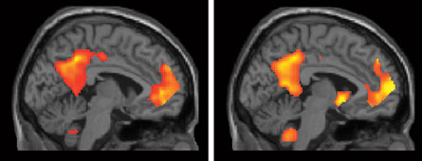

Ideas for Inclusive classrooms
- Video 1: MN State Student Voices Project – Full Video

Impact of an Inclusive campus
- Video 2: MN State Student Voices Project – Full Video

Breakout instructions
- Click on the blue “Join” button that should appear on your screen
- Switch to Group 1 for ASL interpretation or live captioning
- No more than 4 people per room, please

Breakout grounding assumptions
- Be present — however that works for you
- Turn on your camera, if you can
- Ensure everyone shares and holds space together
- Speak from your own experience and ideas
- Everyone is learning. Each journey looks different. Be kind

Let’s Design an Inclusive Presentation or Campus Visit
- Class Presentation for Students of All Bodies & Minds
    - Students show understandings of what they think meaningful inclusion is for a class presentation.
    - How will you design the assignment for the students?
    - How will you ensure all students can share based on their strengths?
- “Why Not This College?” - An Inclusive Campus Visit
    - HS students of all disabilities/abilities will visit campus for a day, including social hour with faculty, staff, and students.
    - How will you design the day to be inclusive and welcoming to all students?
    - What activities could all students join easily on your campus?

Wrap up – Equitable design prerequisites
- Power-sharing infrastructure
- Taps into vast relational networks of different people
- Efforts focus on people most impacted or harmed
- Diversity of lived experiences is a must
- Strengths-based orientation
- What’s one take-away that you will keep or use from today?

Disability justice workshop series
- Disability Justice: Why It’s Everybody’s Business – Jan 26
- Racial Justice & Disability Justice: Working Together to Free Our Minds & Bodies – Feb 23
- New Ways to Talk About Disability – March 30
- Experience Is Our Teacher: People with Disabilities on Allyship, Advocacy, & Pride – April 27
- From Vision to Action: Let’s Create Inclusive Classrooms, Campuses & Communities – May 4

Further resources
- Student Voices videos in full (Need MN State affiliation to access) ​
- Example of inclusive language in syllabus by Lydia X. Z. Brown ​
- Intelligent Lives film by Dan Habib​
- MN Inclusive Higher Education Consortium (MIHEC)​
- The Field Guide to Human Centered Design by IDEO​
- One Without the Other: Stories of Unity Through Diversity and Inclusion by Shelley Moore, 2016​
- Black, Disabled, and Proud: COLLEGE STUDENTS WITH DISABILITIES​
- National Center for College Students with Disabilities​
- THINK College -Center for inclusive college for students with intellectual disabilities​
- MNLEND Paid leadership fellowship on neurodevelopmental disabilities + policy/systems change [Application reopens Oct 15, 2022, for the 2023-24 cohort].​
- Association of Higher Education & Disabilities (AHEAD, National) + MN AHEAD Chapter​
- Accessible handout and recording of today’s session (to be posted within a week)

Disability Justice is Everybody’s Business

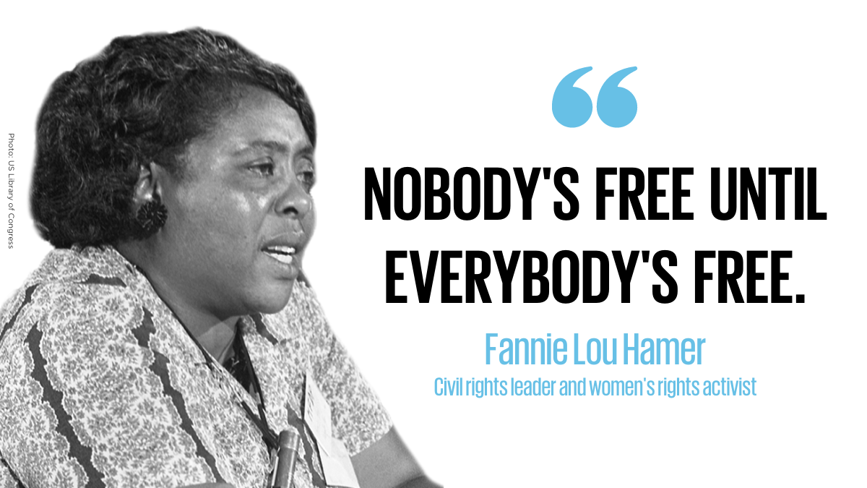

Thank you

